Ruixin Chen

Professor Jochen G. Raimann

[Computational Stats & Prob.](https://yu.instructure.com/courses/64812)

01 May 2024

# **The Relationship between Fertility and Mental Health in Females**

****Abstract:**** This study examines the relationship between fertility and mental health in females using data from the NHANES database. Specifically, we investigate whether females who gave birth to their first baby when they were underaged or who have more than two babies are more prone to experiencing poor mental health. This study investigates the impact and degree of influence of the age of first childbirth, number of pregnancies, and parity on women's mental health, aiming to explore practical issues such as the age range for childbearing that supports psychological well-being. These results underscore the importance of understanding the impact of fertility on women's mental well-being.

****Keywords:**** fertility, mental health, NHANES, early childbirth, motherhood penalty

## **Introduction**

The term "motherhood penalty" has traditionally been used to describe the negative impact experienced by women in the economic sphere after becoming mothers. The motherhood penalty refers to a loss of human capital when women become mothers and subsequently take time off work, divide their attention between their jobs and home, and make other potentially detrimental career decisions based on their children.

In fact, the impact of this "penalty" is not limited to the economic sphere; it also has profound implications at the psychological level for women. This study aims to validate the existence of this "penalty" in terms of mental health and to identify potential influencing factors and their degree of impact.. Understanding the relationship between fertility and mental health in females is crucial for informing public health initiatives and supporting women's well-being. This study aims to clarify this relationship using data from the NHANES database.

## **Objectives**

The objectives of this study are fourfold:

1. To investigate whether the penalty in mental health exists for females, which means that females who are mothers have a higher probability of experiencing poor mental health.
2. To find out if conditions such as the age at which women have their first child, the number of pregnancies, and the number of children born influence female mental health.e female mental health.
3. To explore the degree of influence of each factor.
4. To identify the age range of first childbirth that corresponds to female mental health being above the average health level, and attempt to establish a model relating these factors to female mental health.

## **Materials and Methods**

### **Data Source**

Data for this study were obtained from the National Health and Nutrition Examination Survey (NHANES) database.

### **Study Design**

This study extracted female data from the NHANES database. Initially, it divided them into groups based on whether they had given birth or not. Then, within the group of women who had given birth, further subgrouping was conducted based on whether their first child was born when they were adults, the number of children they had (whether it exceeded 2), and whether there were instances of pregnancy without childbirth. Based on these, the steps are:

1. Compare the childbirth group and the non-childbirth group in terms of sleep patterns, presence of depression, feelings of low interest, and the proportion of individuals experiencing poor mental health each month to determine if there is a "penalty".
2. Compare the four indicators between the group that gave birth as adults and the group that gave birth as minors. Analyze the data and charts to determine if reaching adulthood at the time of first childbirth is a influencing factor. Based on the hypothesis, the levels of the four indicators in the group that gave birth as minors are expected to be lower than the overall female population, while the group that gave birth as adults is expected to exhibit the opposite trend.
3. Compare the four indicators between the group with more than two children and the group with fewer than two children. Analyze the data and charts to determine if reaching adulthood at the time of first childbirth is a influencing factor. Based on the hypothesis, the levels of the four indicators in the group with more than two children are expected to be lower than the overall female population, while the group with fewer than two children is expected to exhibit the opposite trend.
4. Compare the four indicators between the group with pregnancies but no childbirth and the group without pregnancies and childbirth. Analyze the data and charts to determine if reaching adulthood at the time of first childbirth is an influencing factor. Based on the hypothesis, the levels of the four indicators in the group with pregnancies but no childbirth are expected to be lower than the overall female population, while the group without pregnancies and childbirth is expected to exhibit the opposite trend.
5. Further conduct Pearson correlation coefficient analysis on these influencing factors based on the chart situation to determine their correlation and degree of correlation.
6. Further determine the recommended age range for childbirth from a mental health perspective.
7. Attempt to establish a model for the relationship between female childbirth and mental health based on the explored factors (using multiple linear regression and KNN algorithm).

### **Data Analysis**

Descriptive statistics were computed for each sample, including median, mean, and confidence intervals. Correlation analyses were conducted to assess the relationship between childbirth factors and mental health indicators (e.g., bad mental health days, depression, sleep quality).

1. Comparing the overall female population to the subset of mothers and non-mothers, across variables such as sleep duration, level of depression, presence of decreased interest, and the proportion of monthly psychological unhealthiness. The result is as following.

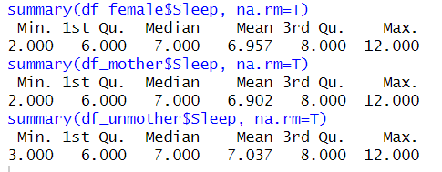

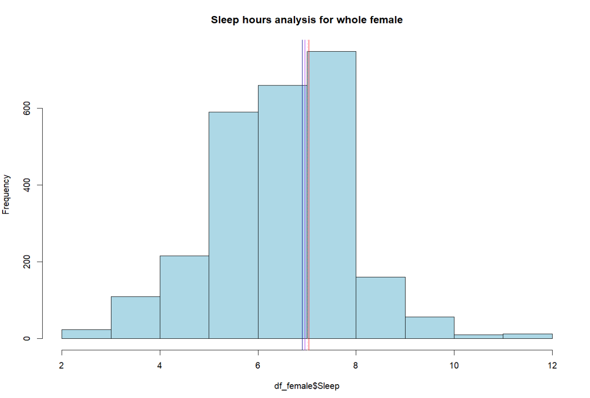Figure 1. histogram about sleep duration of whole female

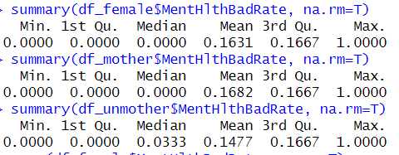

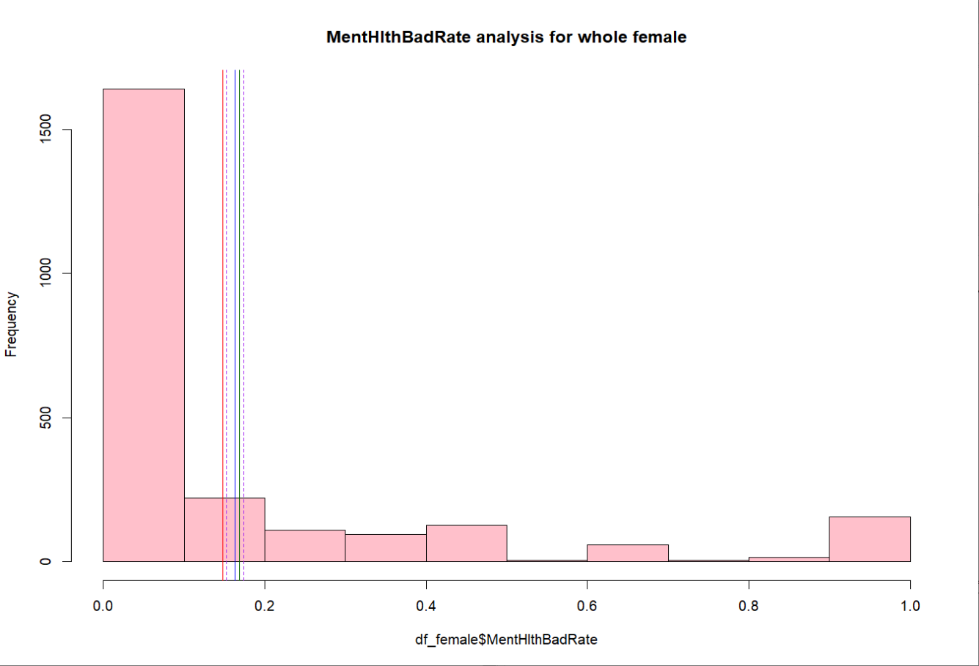Figure 2. histogram about proportion of monthly psychological unhealthiness of whole female

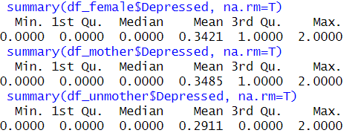

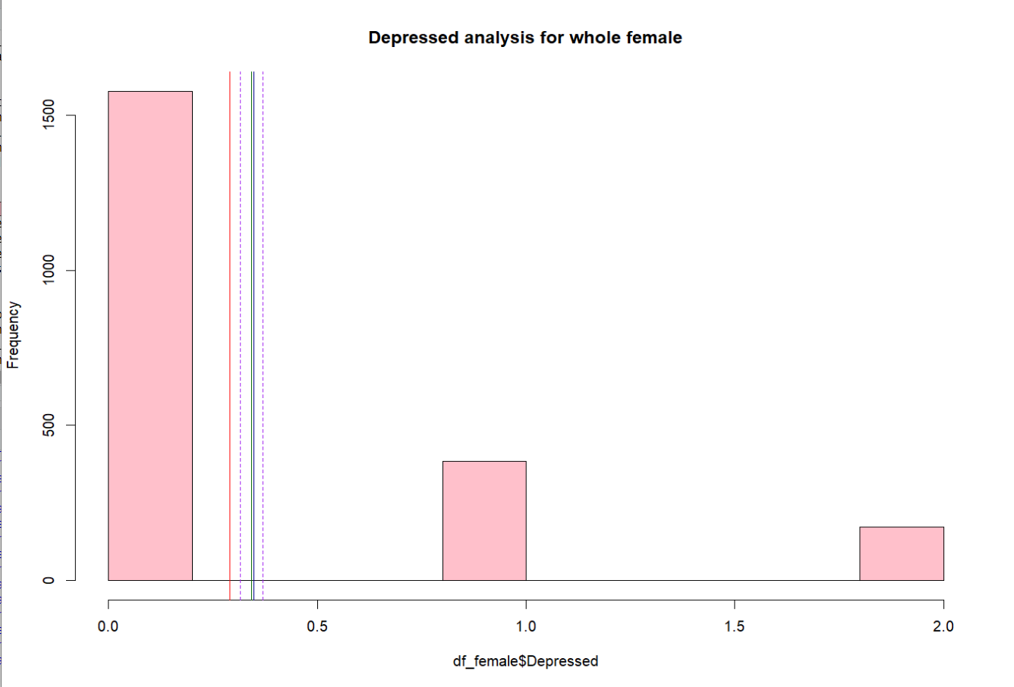Figure3. histogram about level of depression of whole female

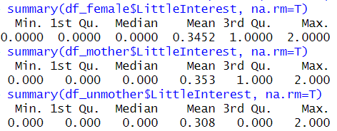

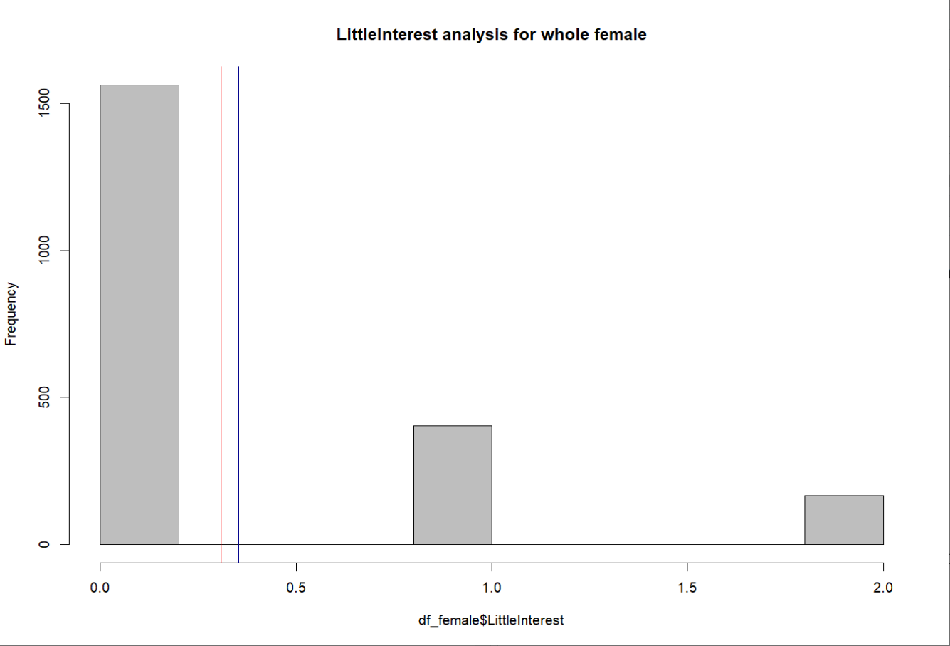Figure4. histogram about presence of decreased interest of whole female

Based on the results, it is not difficult to find that the four psychological indicators of non-mother samples are all superior to the overall female mean, while the mother samples are the opposite, proving that there is indeed some kind of "penalty", and there is a certain correlation mechanism between female mental health and childbirth.

1. Comparing sleep duration, level of depression, presence of decreased interest, and the proportion of monthly psychological unhealthiness between the group with more pregnancies than births and the group with no more more pregnancies than births.

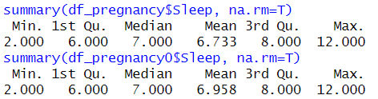

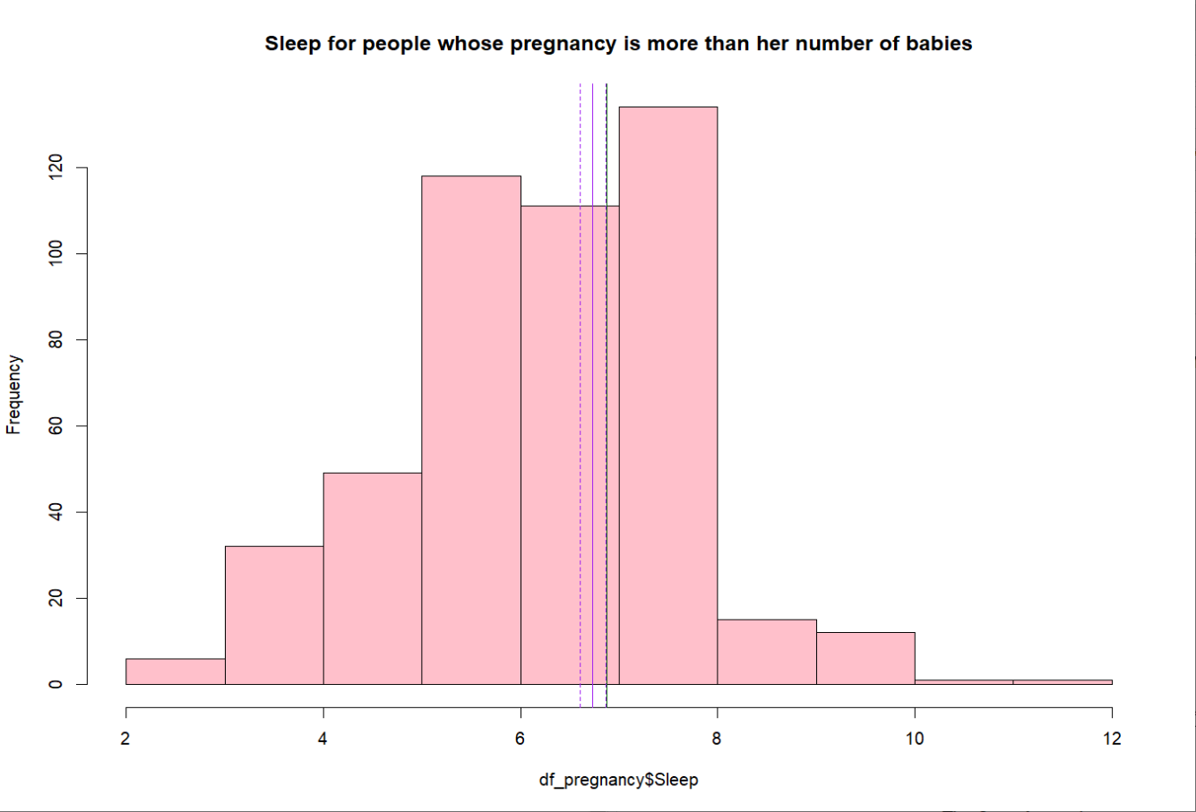Figure5. histogram about sleep duration of female who has more pregnancies than births

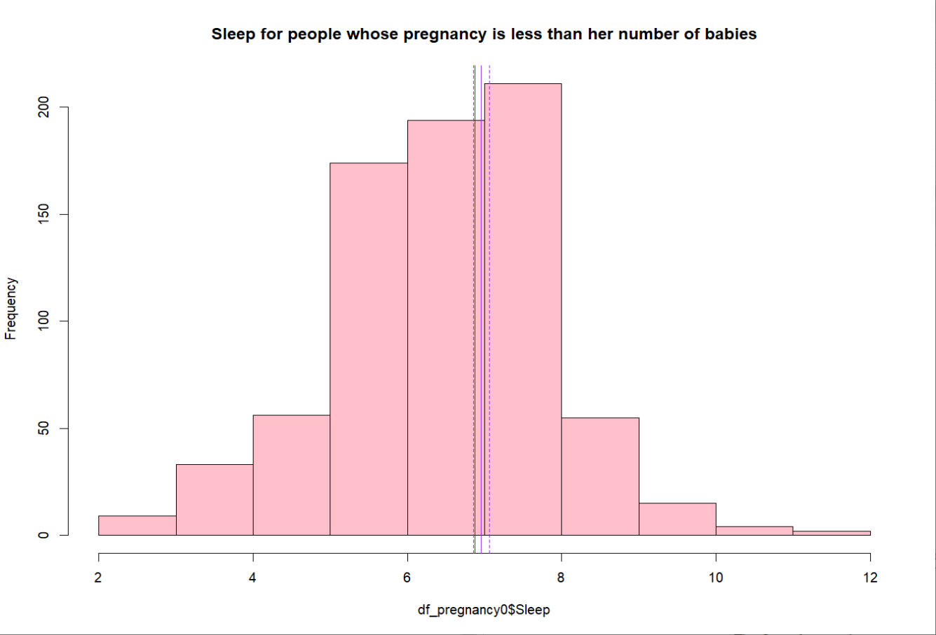Figure6. histogram about sleep duration of female who has no more pregnancies than births

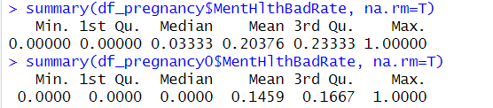

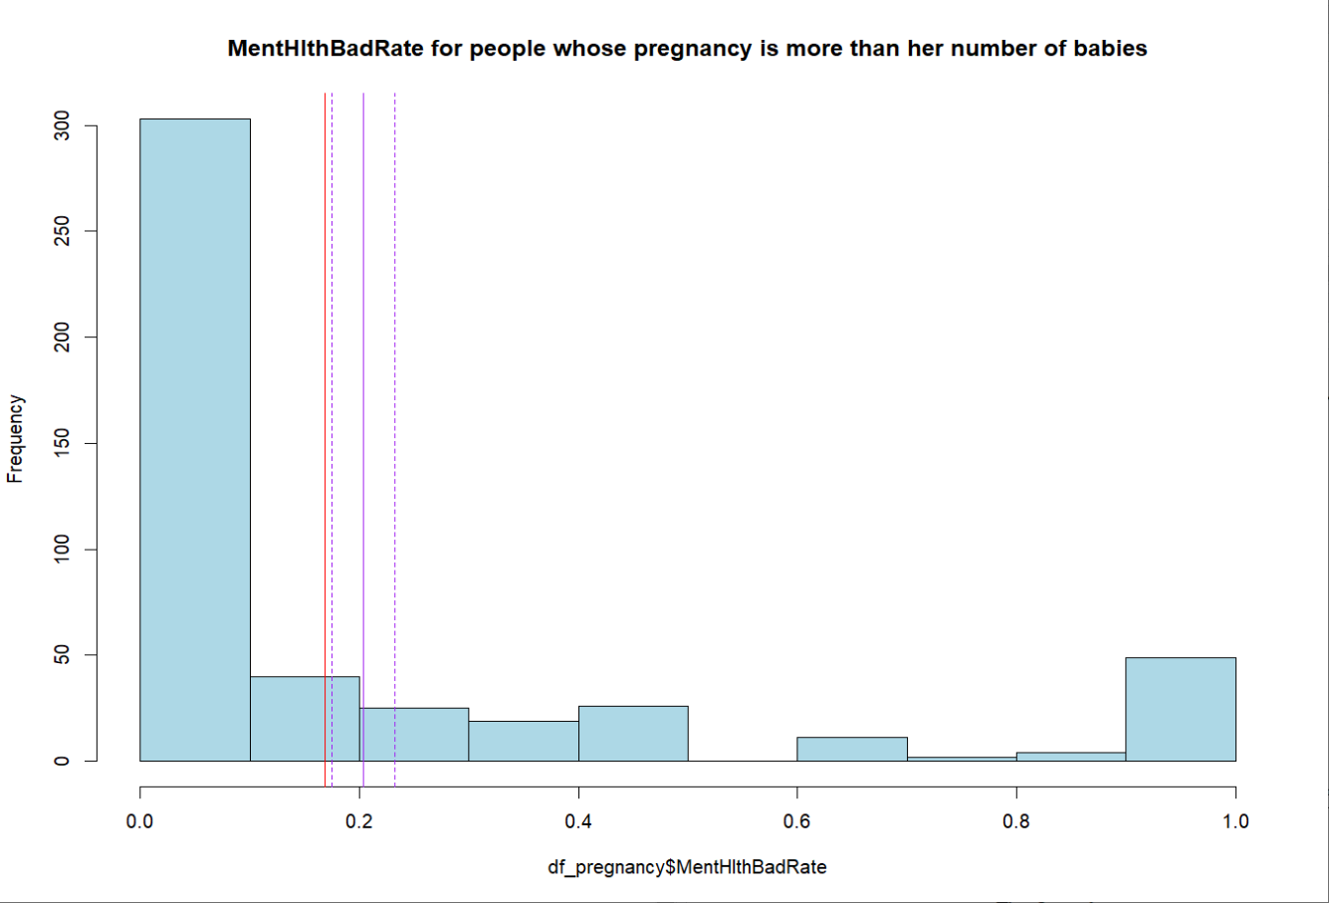Figure7. histogram aboutthe proportion of monthly psychological unhealthiness of female who has more pregnancies than births

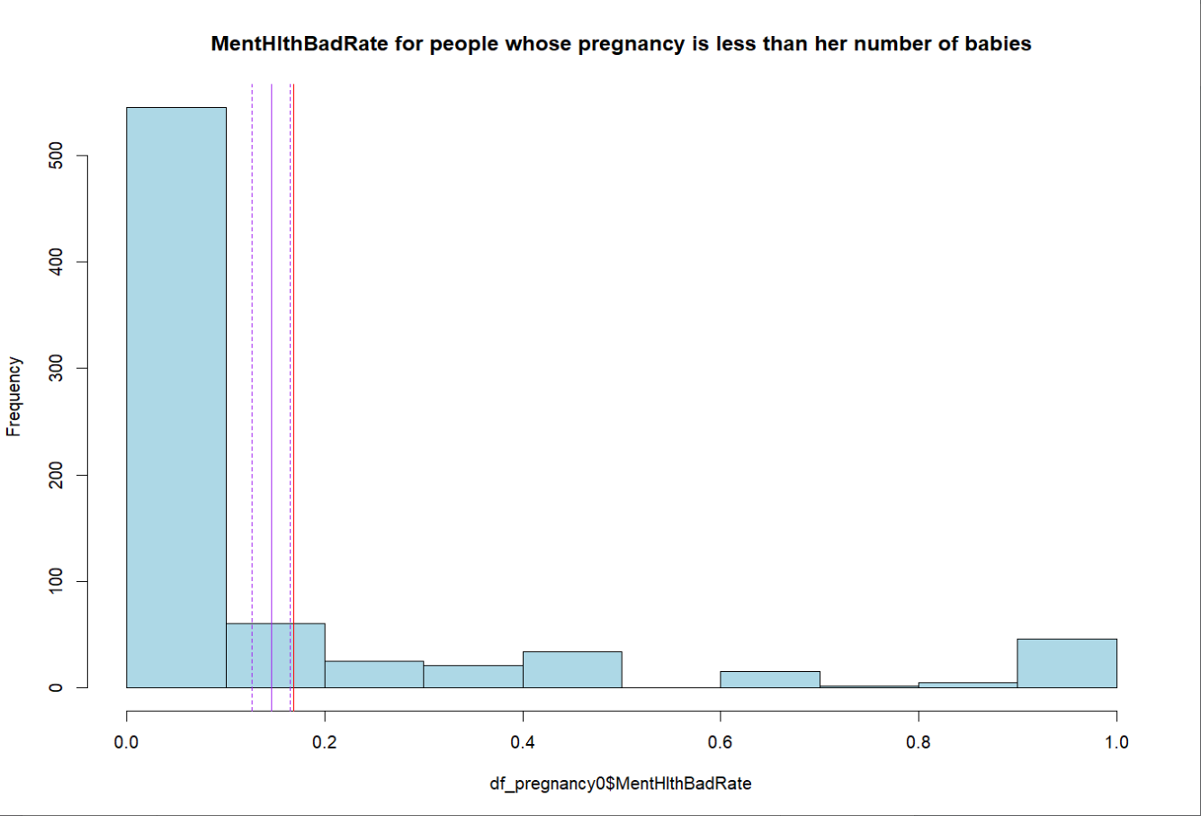Figure8. histogram about the proportion of monthly psychological unhealthiness of female who has no more pregnancies than births

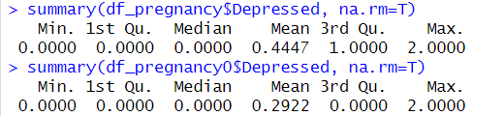

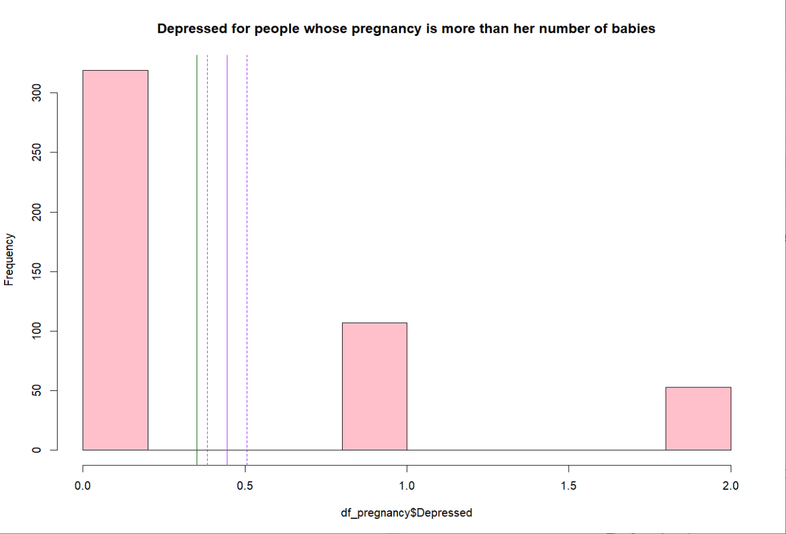Figure9. histogram about level of depression of female who has more pregnancies than births

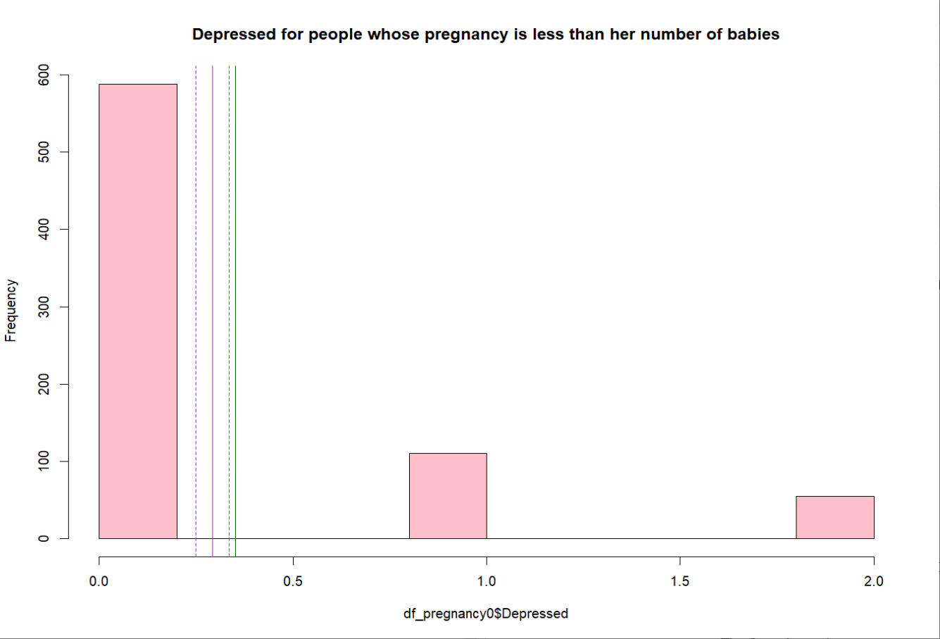Figure10. histogram about level of depression of female who has no more pregnancies than births

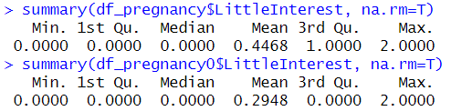

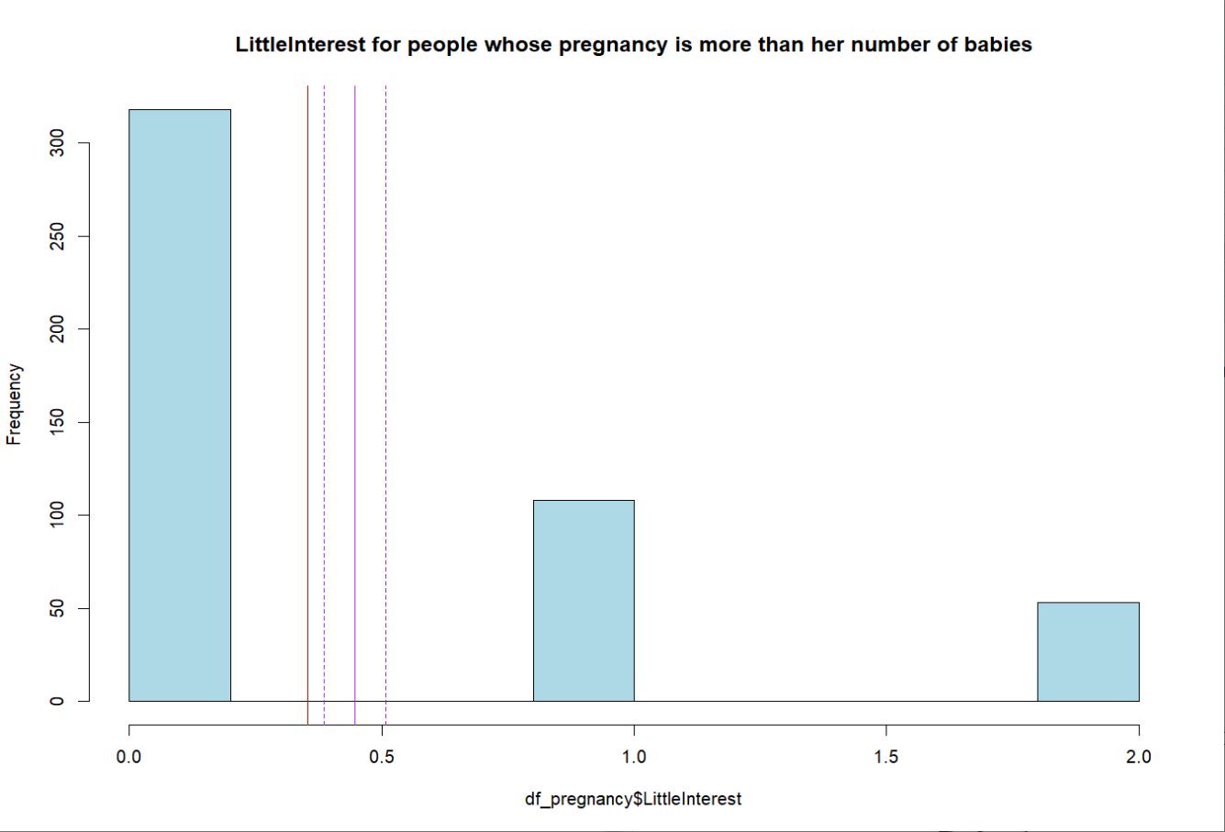Figure11. histogram about presence of decreased interest of female who has more pregnancies than births

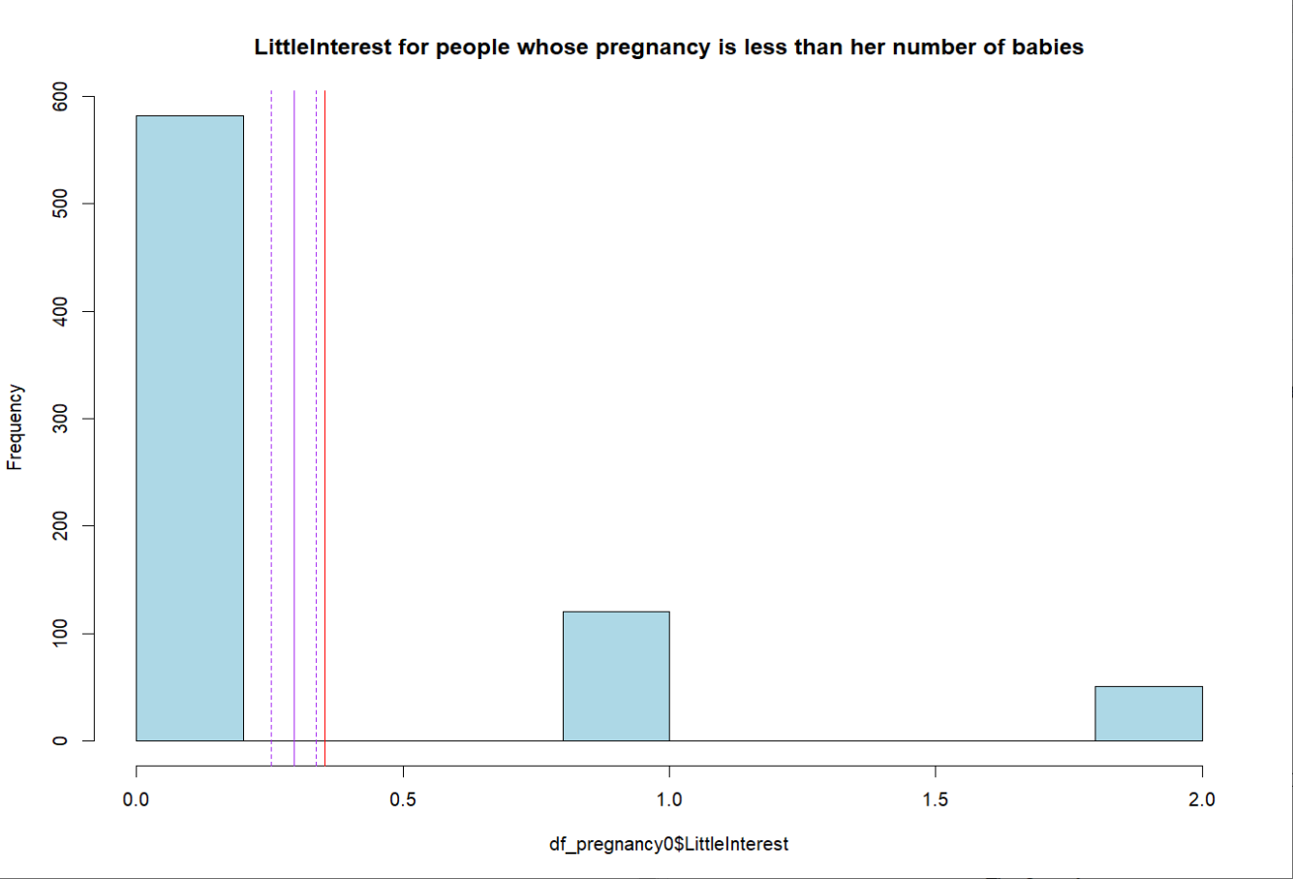Figure12. histogram about presence of decreased interest of female who has no more pregnancies than births

Based on the results, it is evident that the four psychological indicators of samples with a greater number of pregnancies than childbirths are all superior to the overall female mean, while samples with a greater number of pregnancies than childbirths are the opposite. This suggests that having more pregnancies than childbirths is likely to be a contributing factor.

1. Comparing sleep duration, level of depression, presence of decreased interest, and the proportion of monthly psychological unhealthiness between the group with more than 2 babies and the group with 2 or no more than 2 babies.

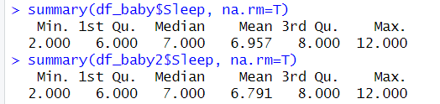

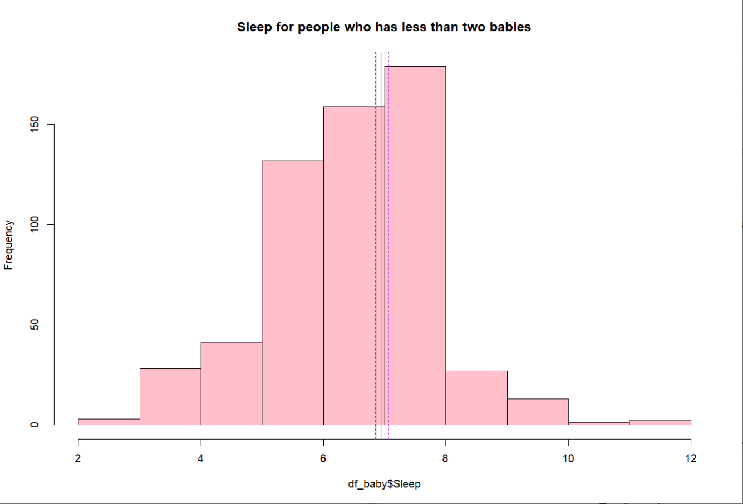Figure13. histogram about sleep duration of female who has more than 2 babies

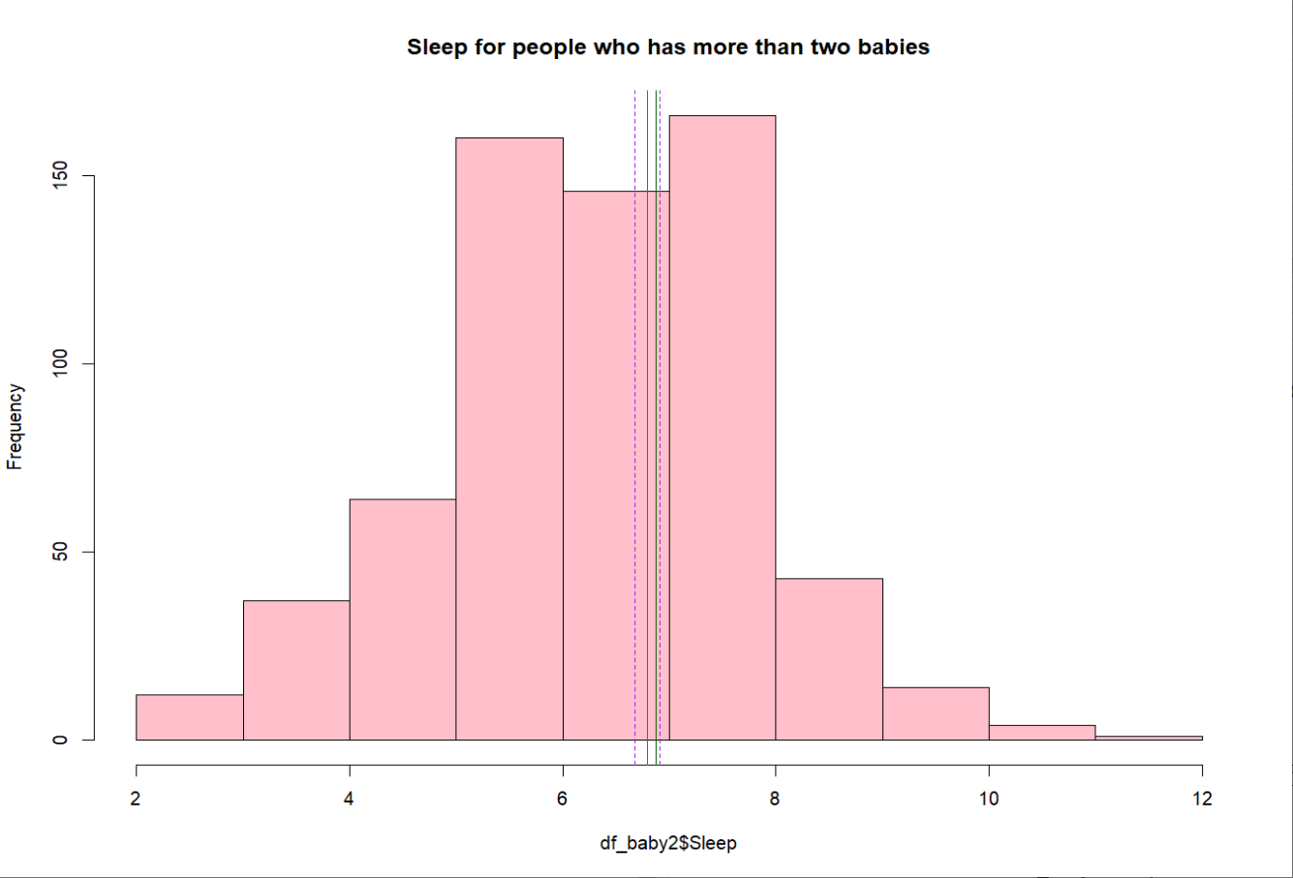Figure14. histogram about sleep duration of female who has no more than 2 babies

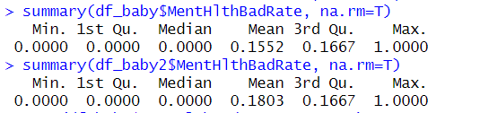

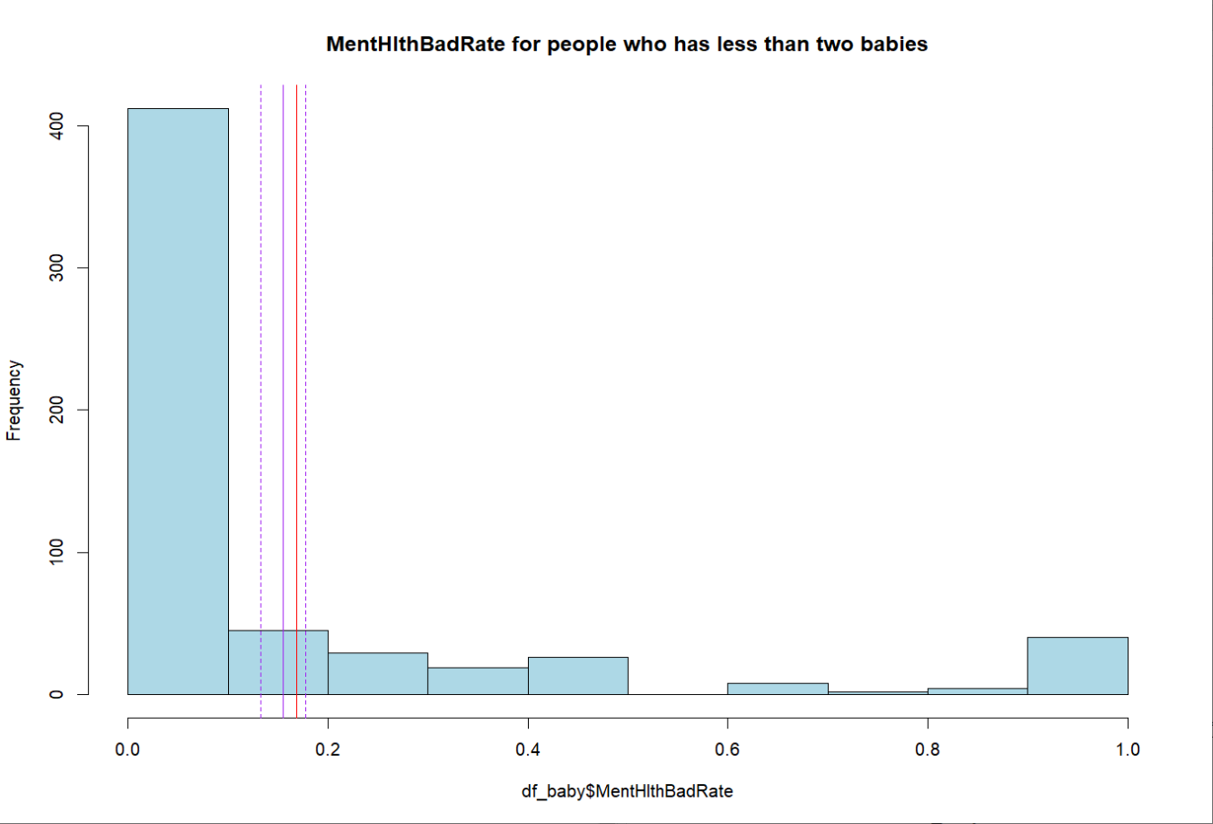Figure15. histogram about the proportion of monthly psychological unhealthiness of female who has more than 2 babies

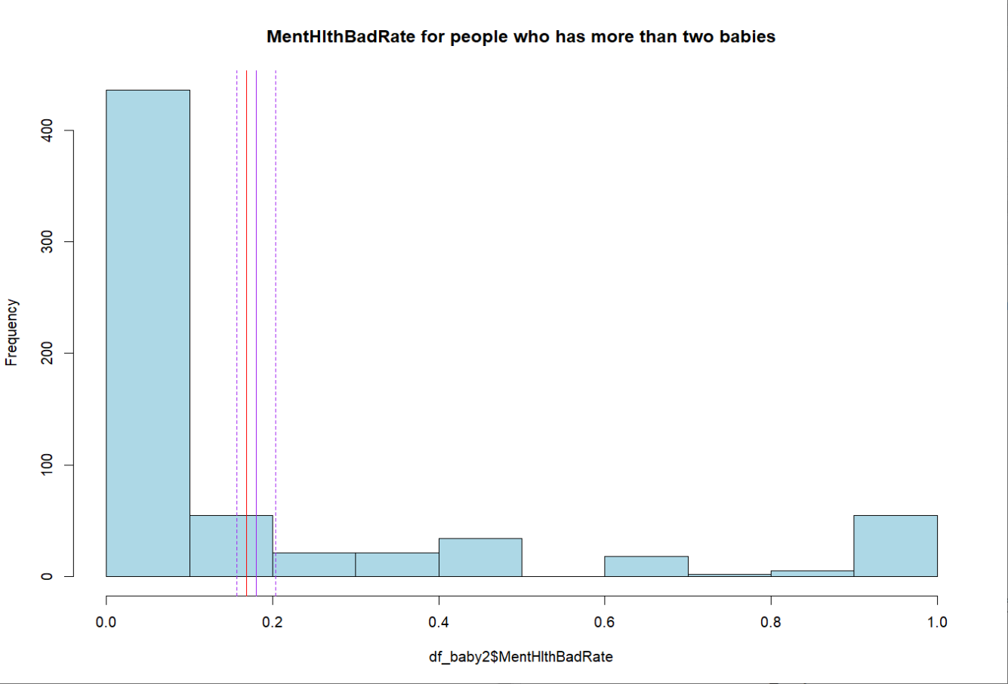Figure16. histogram about the proportion of monthly psychological unhealthiness of female who has no more than 2 babies

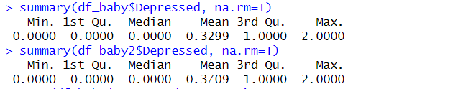

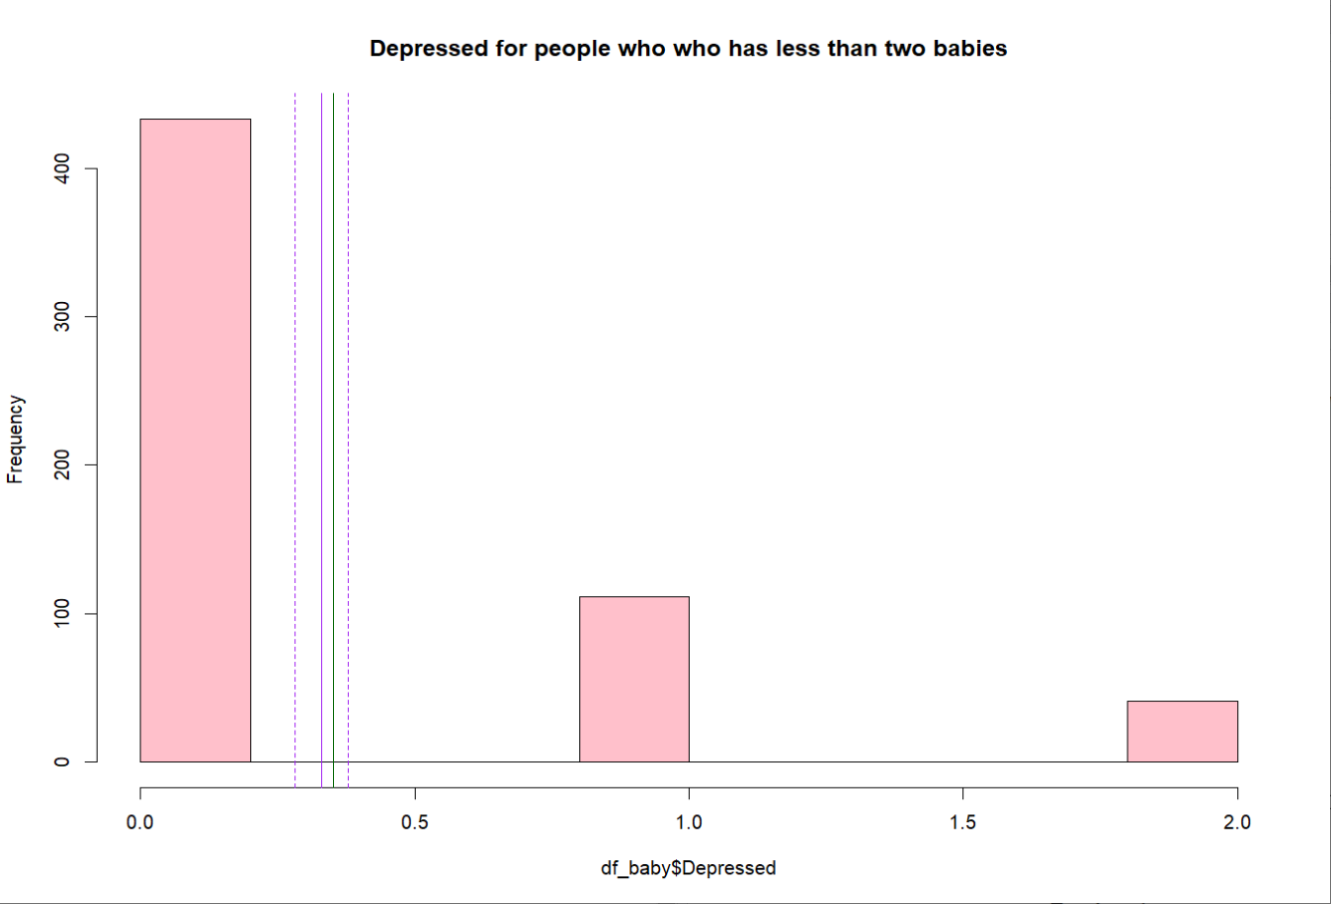Figure17. histogram about level of depression of female who has more than 2 babies

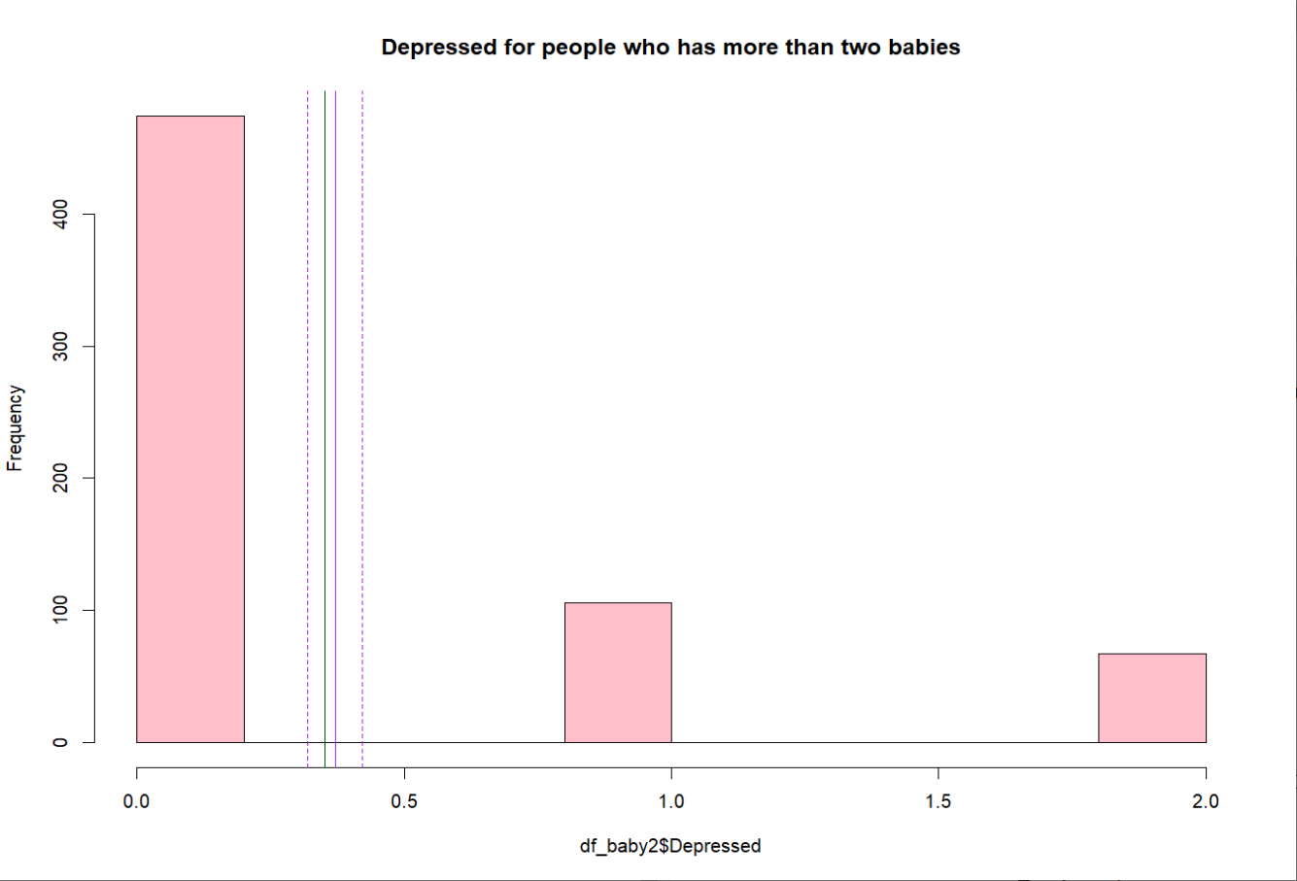Figure18. histogram about level of depression of female who has no more than 2 babies

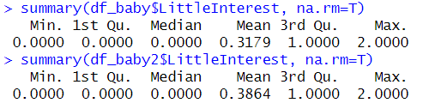

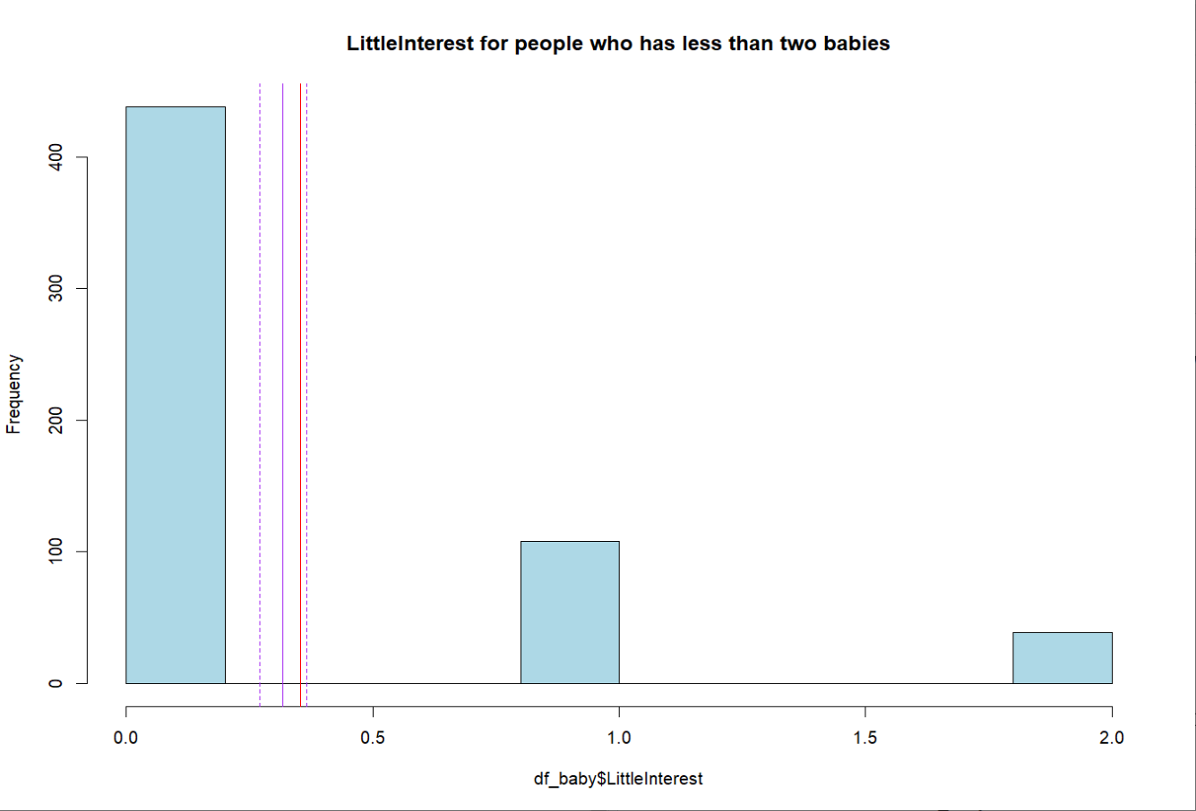Figure19. histogram about presence of decreased interest of female who has more than 2 babies

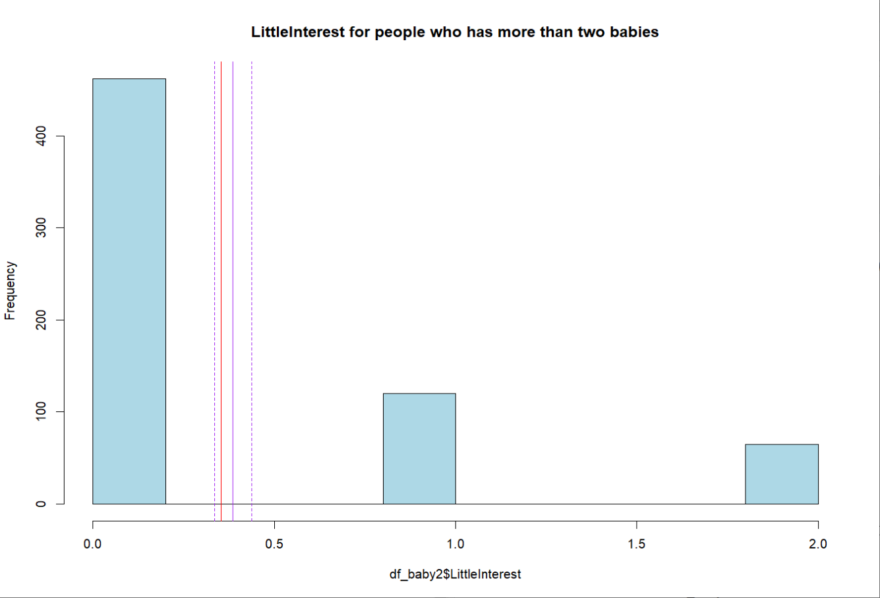Figure20. histogram about presence of decreased interest of female who has no more than 2 babies

Based on the results, it is evident that the four psychological indicators of samples with a childbirth count less than or equal to 2 are all superior to the overall female mean, while samples with a childbirth count greater than 2 are the opposite. This suggests that the number of childbirths is likely to be a correlated factor.

1. Comparing sleep duration, level of depression, presence of decreased interest, and the proportion of monthly psychological unhealthiness between the group of adolescent pregnancies and the group of adult pregnancies.

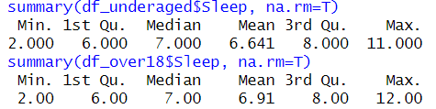

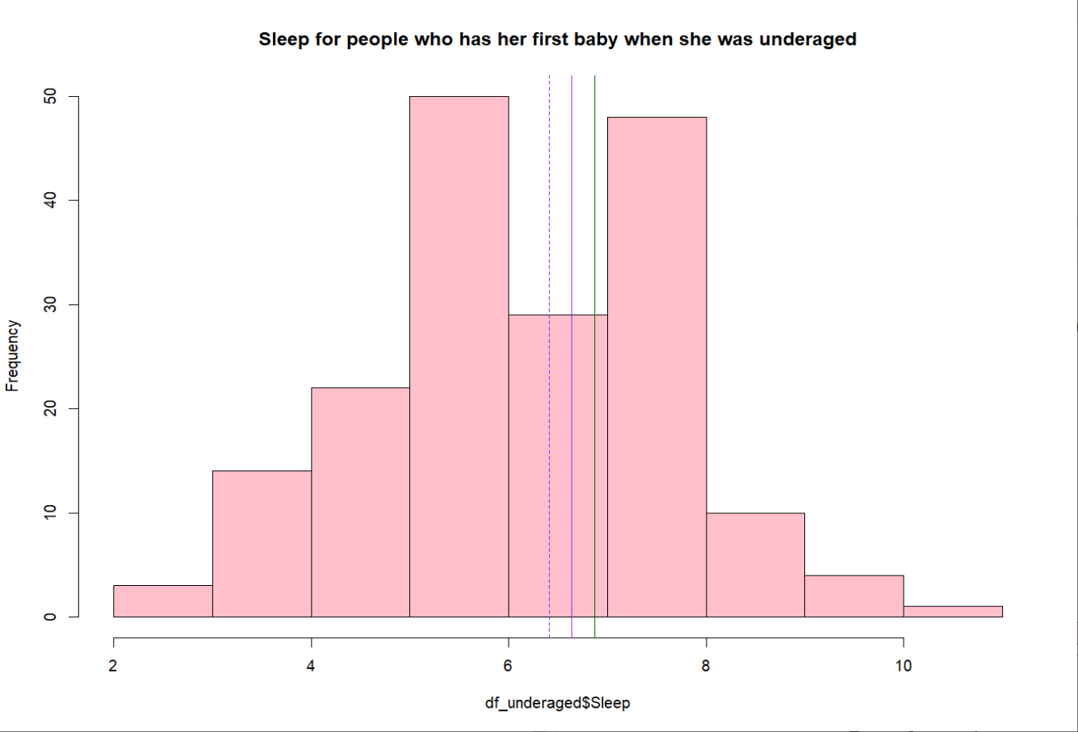Figure21. histogram about sleep duration of female who has her first baby when she is underaged

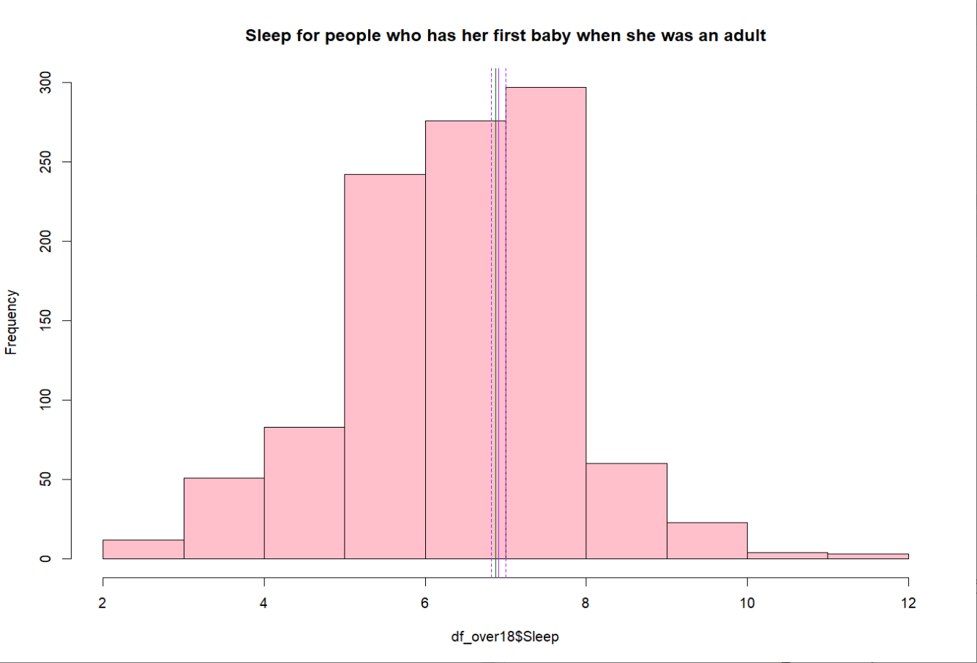Figure20. histogram abou tsleep duration of female who has her first baby when she is an adult

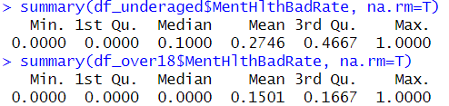

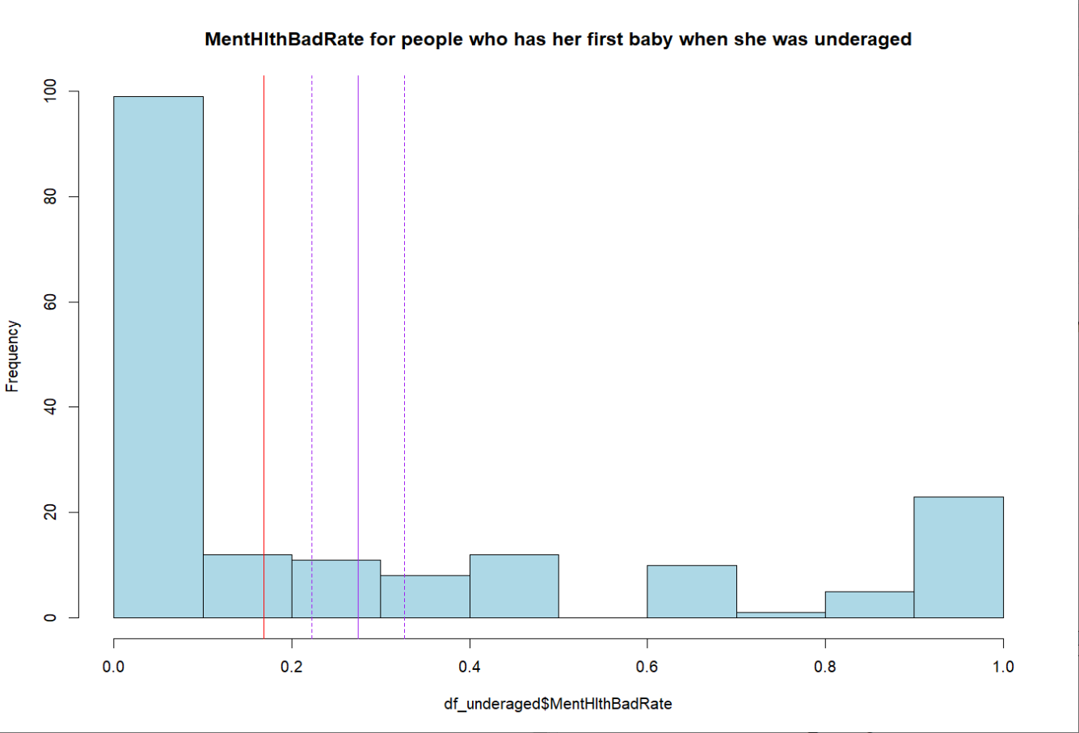Figure21. histogram about the proportion of monthly psychological unhealthiness of female who has her first baby when she is underaged

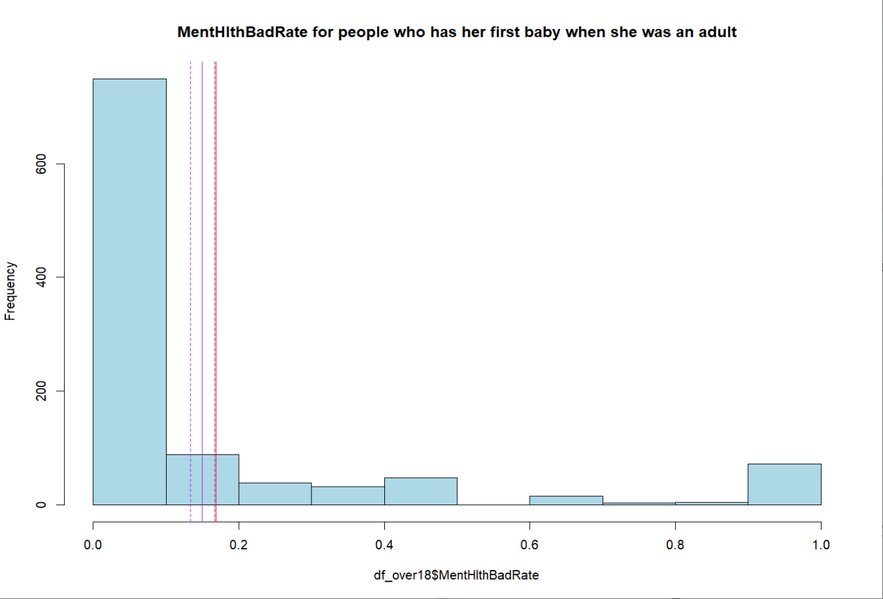Figure22. histogram about the proportion of monthly psychological unhealthiness of female who has her first baby when she is an adult

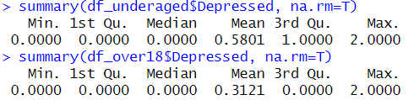

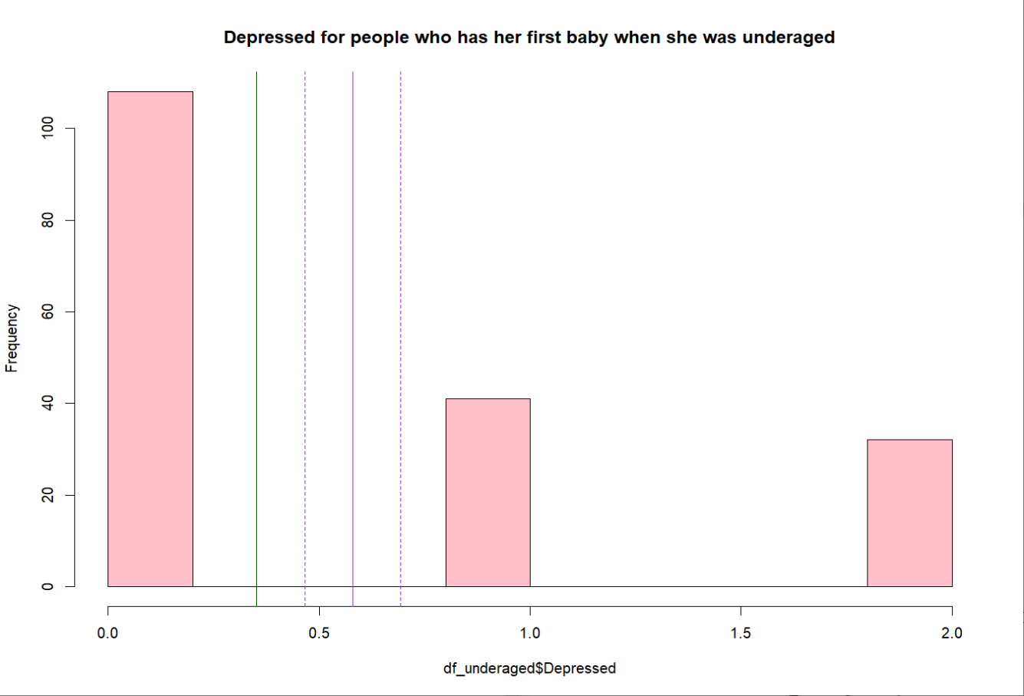Figure23. histogram about level of depression of female who has her first baby when she is underaged

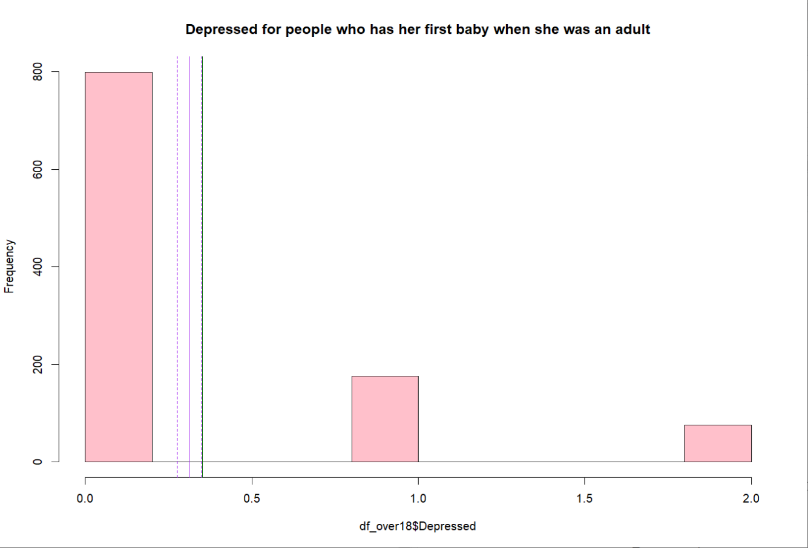Figure24. histogram about level of depression of female who has her first baby when she is an adult

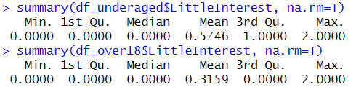

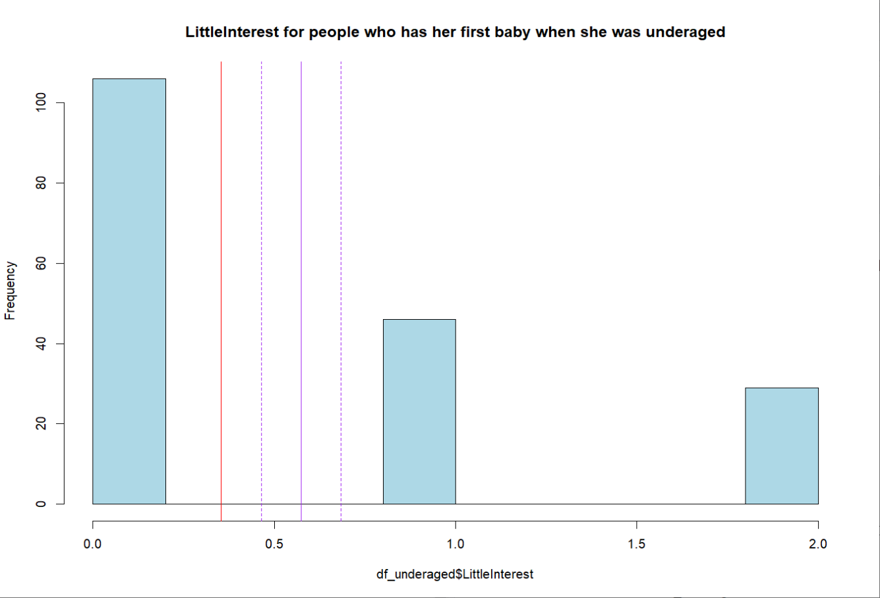Figure25. histogram about presence of decreased interest of female who has her first baby when she is underaged

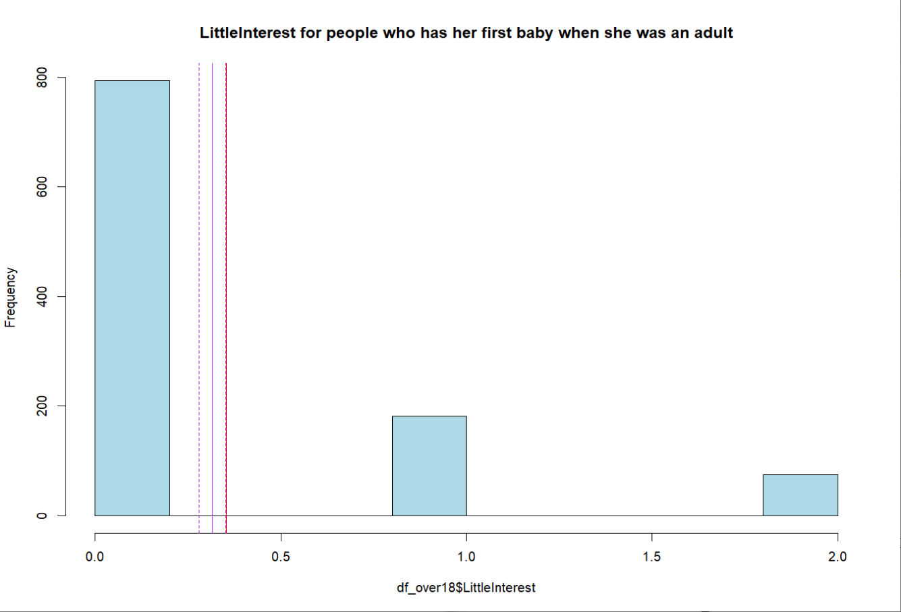Figure26. histogram about presence of decreased interest of female who has her first baby when she is an adult

Based on the results, it is evident that the four psychological indicators of samples who first gave birth during adulthood are all superior to the overall female mean, while samples who first gave birth during adolescence are the opposite. This suggests that the age of first childbirth is likely to be a correlated factor.

1. Conducting a correlation analysis between the age of first childbirth and sleep duration.
2. Correlation between FirstBaby and Sleep: 0.0731272

t-value: 2.571555

p-value: 0.01024091

This analysis suggests that there is a certain degree of correlation between the age of first childbirth in women and sleep. Specifically, the correlation coefficient is 0.0731272, indicating a relatively weak linear relationship between the age of first childbirth and sleep. However, through the analysis of the t-value and p-value, we can conclude that this correlation is statistically significant. The t-value is 2.571555, with a corresponding p-value of 0.01024091 (less than 0.05), indicating that we can reject the null hypothesis, i.e., there is no relationship between the age of first childbirth in women and sleep. Therefore, we can infer that there exists a statistically significant but weak positive correlation between the age of first childbirth in women and sleep.

(2) Correlation between FirstBaby and Depressed: -0.1181335

t-value: -4.172318

p-value: 3.227029e-05

This analysis indicates a negative correlation between the age of first childbirth in women and depression. Specifically, the correlation coefficient is -0.1181335, suggesting that as the age of first childbirth in women increases, the severity of depression may decrease. Through the analysis of the t-value and p-value, we can conclude that this correlation is statistically significant. The t-value is -4.172318, with a corresponding p-value of 3.227029e-05 (less than 0.05), indicating that we can reject the null hypothesis, i.e., there is no relationship between the age of first childbirth in women and depression. Therefore, we can conclude that there exists a statistically significant negative correlation between the age of first childbirth in women and depression.

(3) Correlation between LittleInterest and FirstBaby: -0.09918476

t-value: -3.495782

p-value: 0.0004895006

This analysis indicates a negative correlation between the age of first childbirth in women and the level of low interest. Specifically, the correlation coefficient is -0.09918476, suggesting that as the age of first childbirth in women increases, the level of low interest may decrease. Through the analysis of the t-value and p-value, we can conclude that this correlation is statistically significant. The t-value is -3.495782, with a corresponding p-value of 0.0004895006 (less than 0.05), indicating that we can reject the null hypothesis, i.e., there is no relationship between the age of first childbirth in women and the level of low interest. Therefore, we can conclude that there exists a statistically significant negative correlation between the age of first childbirth in women and the level of low interest.

(4) Correlation between MentHlthBadRate and FirstBaby: -0.1233096

t-value: -4.357895

p-value: 1.422679e-05

This analysis demonstrates a negative correlation between the age of first childbirth in women and the rate of poor mental health. Specifically, the correlation coefficient is -0.1233096, indicating that as the age of first childbirth in women increases, the rate of poor mental health may decrease. Through the analysis of the t-value and p-value, we can conclude that this correlation is statistically significant. The t-value is -4.357895, with a corresponding p-value of 1.422679e-05 (less than 0.05), indicating that we can reject the null hypothesis, i.e., there is no relationship between the age of first childbirth in women and the rate of poor mental health. Therefore, we can assert that there exists a statistically significant negative correlation between the age of first childbirth in women and the rate of poor mental health.

(5) Correlation between Sleep and Babies: -0.04239265

t-value: -1.488105

p-value: 0.1369794

This analysis indicates that there is a correlation between sleep and the number of babies, but it lacks statistical significance. Specifically, the correlation coefficient is -0.04239265, suggesting a weak negative relationship between sleep and the number of babies. However, through the analysis of the t-value and p-value, we find that this correlation is not statistically significant. The t-value is -1.488105, with a corresponding p-value of 0.1369794 (over 0.05). Therefore, we cannot reject the null hypothesis, indicating that there is no significant relationship between sleep and the number of babies.

(6) Correlation between Depressed and Babies: 0.01301082

t-value: 0.4563457

p-value: 0.6482219

This analysis reveals a correlation between depression and the number of babies, yet it lacks statistical significance. Specifically, the correlation coefficient is 0.01301082, indicating a very weak positive relationship between depression and the number of babies. However, upon analyzing the t-value and p-value, it's evident that this correlation is not statistically significant. The t-value is 0.4563457, with a corresponding p-value of 0.6482219 (over 0.05). Consequently, we cannot reject the null hypothesis, suggesting that there is no significant relationship between depression and the number of babies.

(7) Correlation between LittleInterest and Babies: 0.04875284

t-value: 1.711864

p-value: 0.08717381

This analysis indicates a certain degree of correlation between the level of low interest and the number of babies, but it lacks statistical significance. Specifically, the correlation coefficient is 0.04875284, suggesting a weak positive relationship between the level of low interest and the number of babies. However, through the analysis of the t-value and p-value, we find that this correlation is not statistically significant. The t-value is 1.711864, with a corresponding p-value of 0.08717381 (over 0.05). Therefore, we cannot reject the null hypothesis, indicating that there is no significant relationship between the level of low interest and the number of babies.

(8) Correlation between MentHlthBadRate and Babies: 0.02498156

t-value: 0.8764109

p-value: 0.3809778

This analysis indicates a certain degree of correlation between the rate of poor mental health and the number of babies, but it lacks statistical significance. Specifically, the correlation coefficient is 0.02498156, suggesting a weak positive relationship between the rate of poor mental health and the number of babies. However, through the analysis of the t-value and p-value, we find that this correlation is not statistically significant. The t-value is 0.8764109, with a corresponding p-value of 0.3809778 (over 0.05). Therefore, we cannot reject the null hypothesis, indicating that there is no significant relationship between the rate of poor mental health and the number of babies.

(9) Correlation between Sleep and Pregnancy_dif: -0.1113616

t-value: -3.930048

p-value: 8.965845e-05

This analysis indicates a negative correlation between sleep and the difference between pregnancy and childbirth in women, and it is statistically significant. Specifically, the correlation coefficient is -0.1113616, suggesting a slight negative relationship between sleep and the difference between pregnancy and childbirth in women, meaning that individuals with better sleep quality tend to have a smaller difference between pregnancy and childbirth. Through the analysis of the t-value and p-value, we find that this correlation is statistically significant. The t-value is -3.930048, with a corresponding p-value of 8.965845e-05 (less than 0.05), indicating that we can reject the null hypothesis, meaning that there is no relationship between sleep and the difference between pregnancy and childbirth in women.

(10) Correlation between Depressed and Pregnancy_dif: 0.09072444

t-value: 3.195005

p-value: 0.001433804

This analysis demonstrates a positive correlation between the level of depression and the difference between pregnancy and childbirth in women, and it is statistically significant. Specifically, the correlation coefficient is 0.09072444, indicating a slight positive relationship between the level of depression and the difference between pregnancy and childbirth in women, meaning that individuals with higher levels of depression tend to have a larger difference between pregnancy and childbirth. Through the analysis of the t-value and p-value, we find that this correlation is statistically significant. The t-value is 3.195005, with a corresponding p-value of 0.001433804 (less than 0.05), indicating that we can reject the null hypothesis, suggesting that there is a relationship between the level of depression and the difference between pregnancy and childbirth in women.

(11) Correlation between LittleInterest and Pregnancy_dif: 0.1112315

t-value: 3.925399

p-value: 9.1386e-05

This analysis reveals a positive correlation between the level of low interest and the difference between pregnancy and childbirth, and it is statistically significant. Specifically, the correlation coefficient is 0.1112315, indicating a slight positive relationship between the level of low interest and the difference between pregnancy and childbirth, implying that individuals with a higher level of low interest tend to have a larger difference between pregnancy and childbirth. Through the analysis of the t-value and p-value, we find that this correlation is statistically significant. The t-value is 3.925399, with a corresponding p-value of 9.1386e-05 (less than 0.05), suggesting that we can reject the null hypothesis, indicating that there is a relationship between the level of low interest and the difference between pregnancy and childbirth.

(12) Correlation between MentHlthBadRate and Pregnancy_dif: 0.1316379

t-value: 4.657248

p-value: 3.552688e-06

This analysis demonstrates a positive correlation between the rate of poor mental health and the difference between pregnancy and childbirth, and it is statistically significant. Specifically, the correlation coefficient is 0.1316379, indicating a relatively strong positive relationship between the rate of poor mental health and the difference between pregnancy and childbirth, implying that individuals with a higher difference between pregnancy and childbirth tend to have a higher rate of poor mental health. Through the analysis of the t-value and p-value, we find that this correlation is statistically significant. The t-value is 4.657248, with a corresponding p-value of 3.552688e-06 (less than 0.05), suggesting that we can reject the null hypothesis, indicating that there is a relationship between the rate of poor mental health and the difference between pregnancy and childbirth.

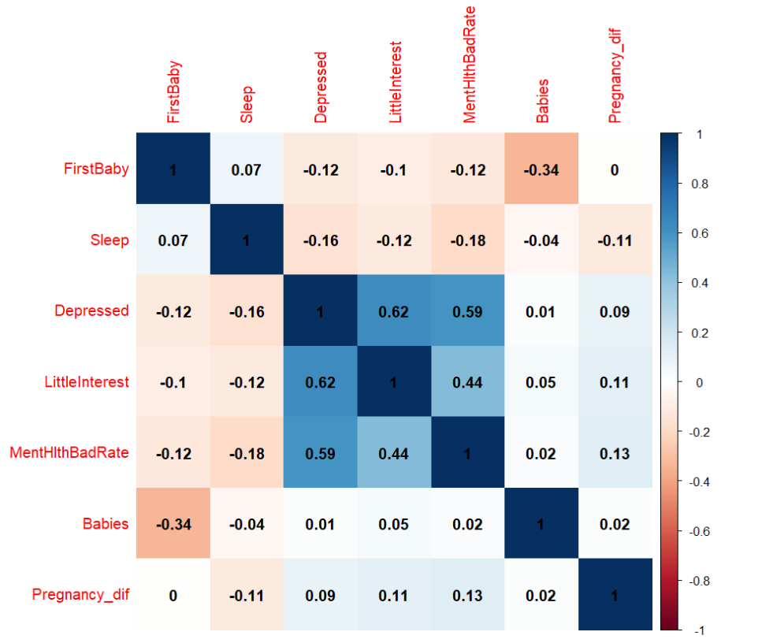

Figure26. heatmap about the relationship beween factors

According to the heatmap, we can also observe that the factors with relatively high comprehensive psychological correlations are the difference between pregnancy and childbirth in women and the age of first childbirth, while the number of children born shows some correlation but is relatively weak.

1. To identify a range of reproductive age conducive to maintaining mental health.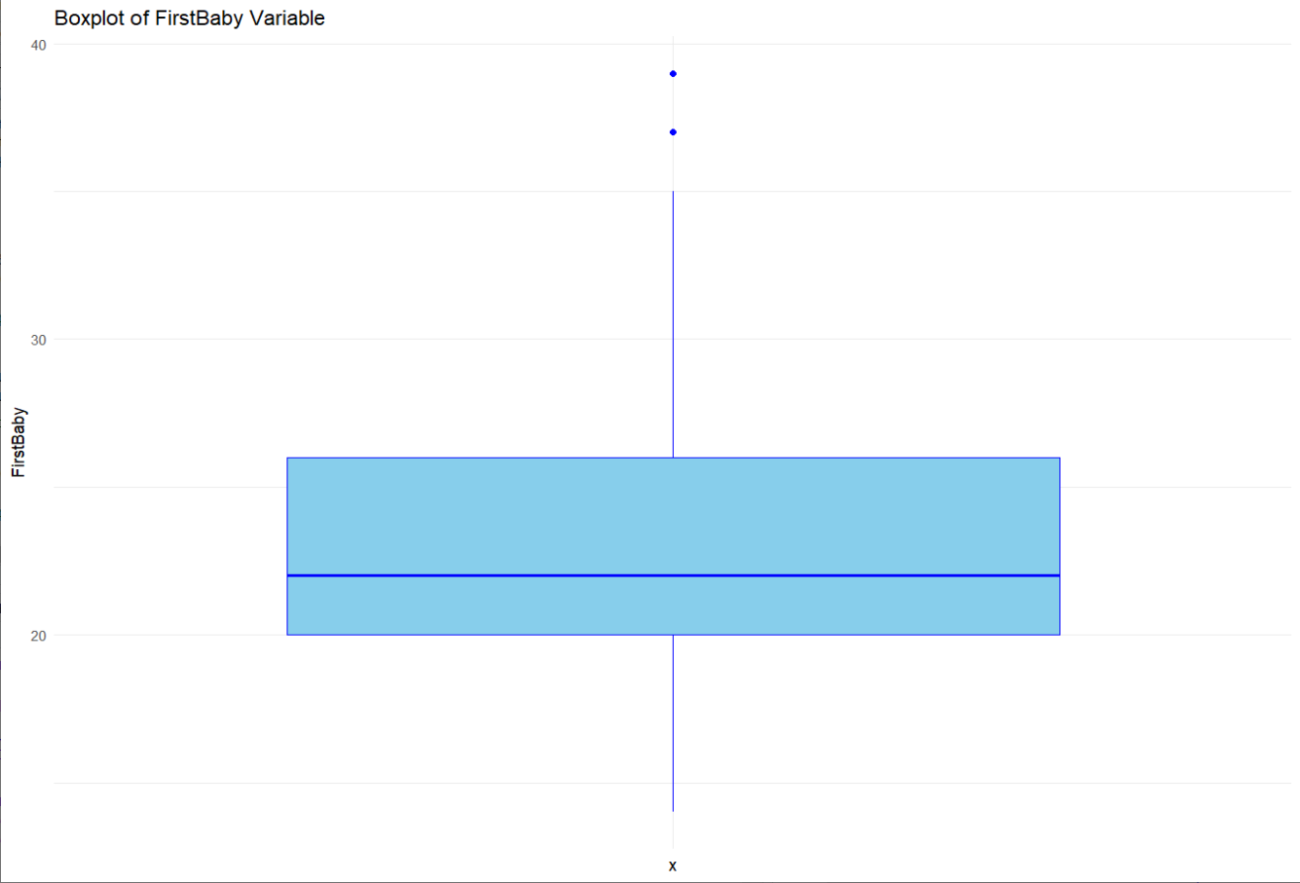

Figure27. Boxplot of the age of female has her first baby

1. The range is between 20-35.

To identify a range of pregnancies exceeding births conducive to maintaining mental health in female.

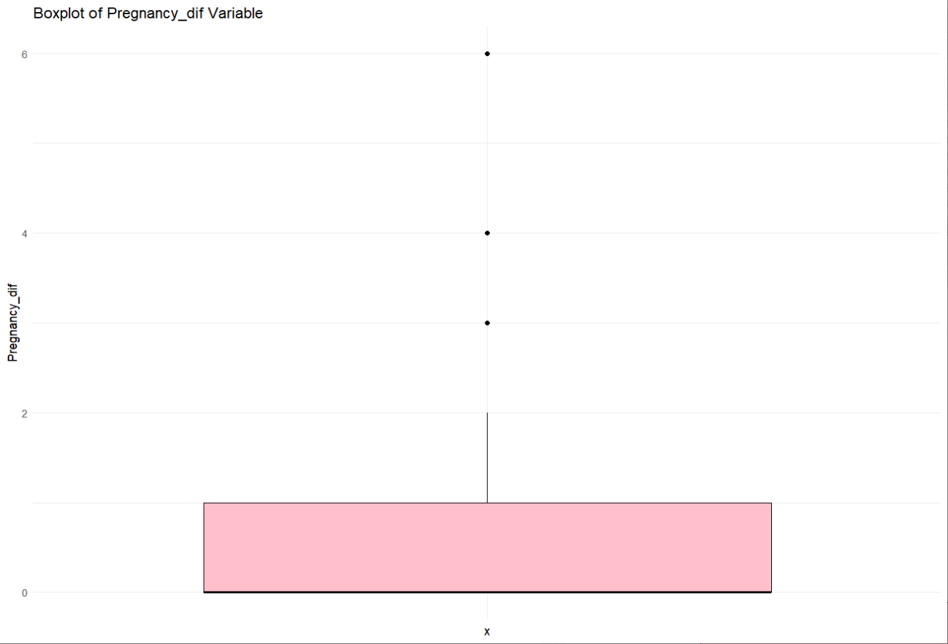Figure28. Boxplot of the difference between pregnancies and childbirths

The range is between 0 and 1

1. Based on these ranges, creating sample for validation.

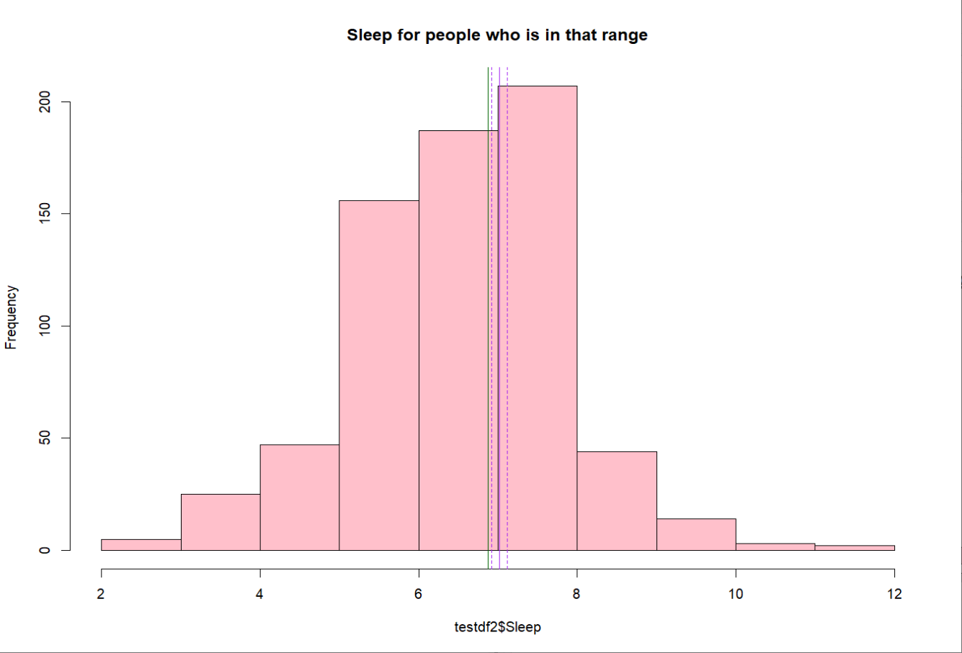Figure29. histogram about sleep duration of the female in this new sample which based on that range

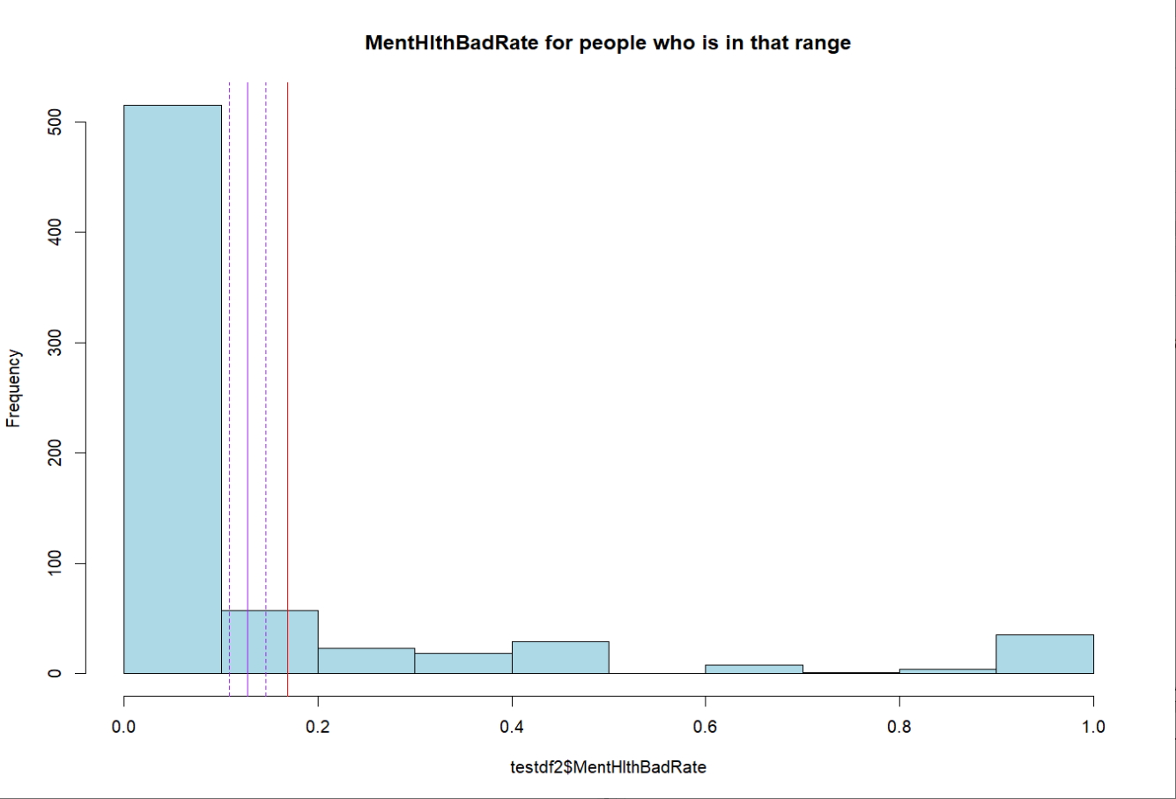Figure30. histogram about the proportion of monthly psychological unhealthiness of the female in this new sample which based on that range

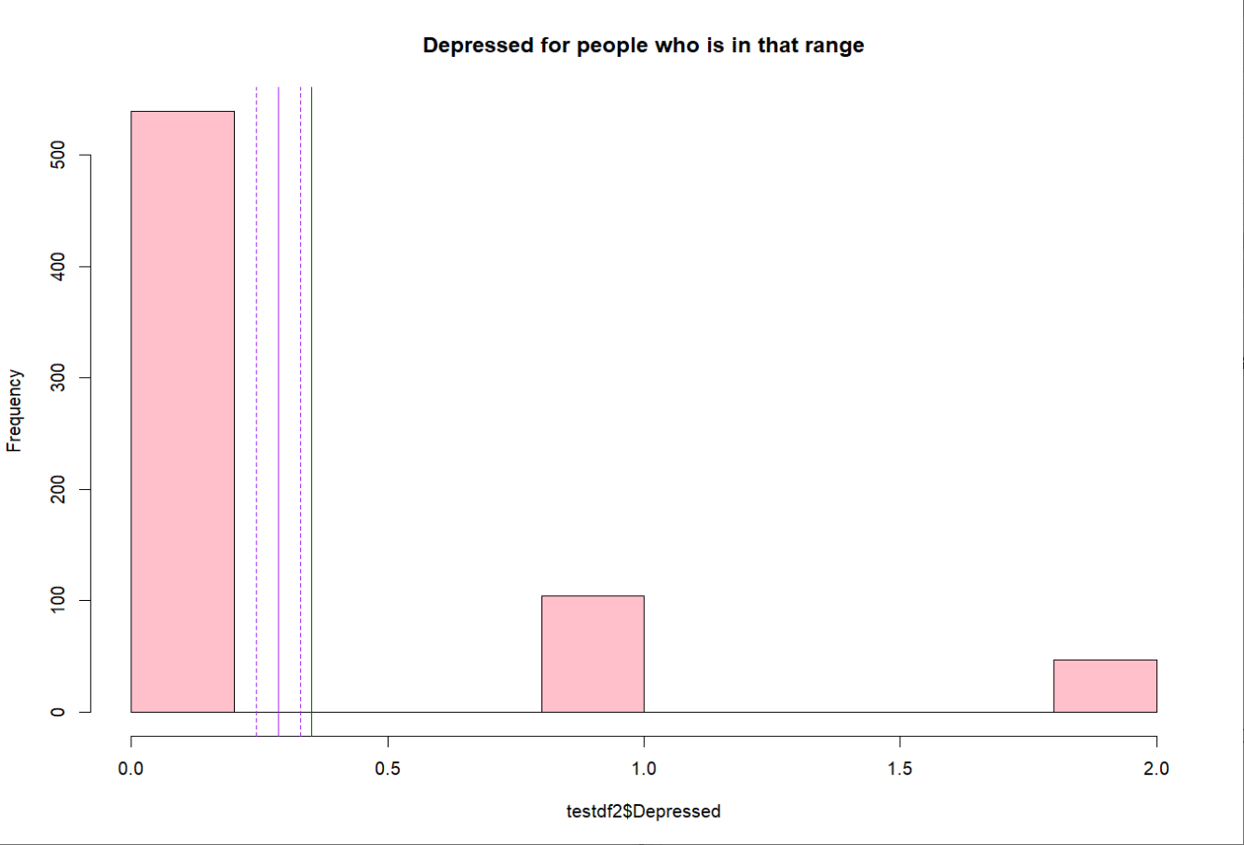Figure31. histogram about level of depression of the female in this new sample which based on that range

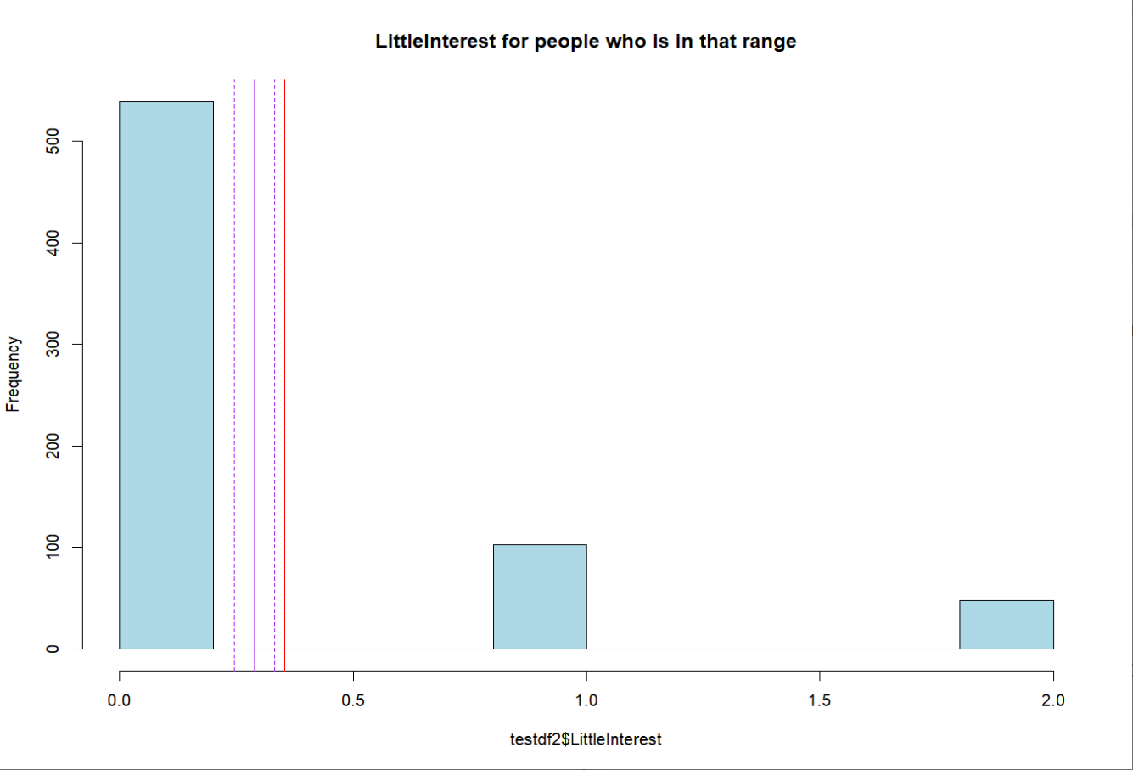Figure32. histogram about presence of decreased interest of the female in this new sample which based on that range

It's obviously that within this range, 95% of individuals exhibit four indicators that are superior to the mean, indicating a relatively healthy level.

1. Based on the correlation results, attempt to establish a model.
2. Sleep:

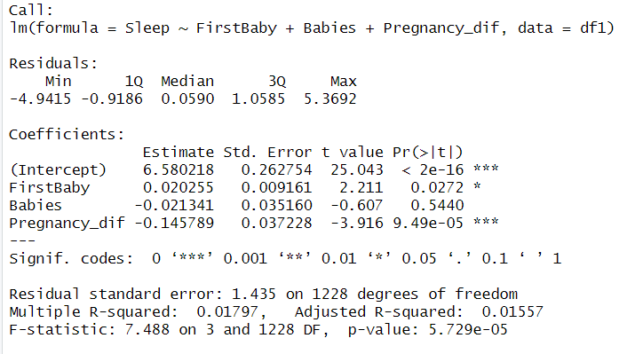

According to the results of the multivariable linear regression analysis:

The intercept is 6.580218. The coefficient estimate for FirstBaby (age at first childbirth) is 0.020255, for Babies (number of children born) is -0.021341, and for Pregnancy_dif (difference between pregnancy and childbirth) is -0.145789.

The p-value for FirstBaby is 0.0272, which is less than 0.05, indicating a significant effect of age at first childbirth on sleep.

The p-value for Babies is 0.5440, which is greater than 0.05, indicating a non-significant relationship between the number of children born and sleep.

The p-value for Pregnancy_dif is 9.49e-05, much less than 0.05, indicating a significant effect of the difference between pregnancy and childbirth on sleep.

The multiple R-squared value is 0.01797, and the adjusted R-squared value is 0.01557, suggesting that the model explains a relatively low amount of variability in the data.

The F-statistic is 7.488, with a corresponding p-value of 5.729e-05, less than 0.05, indicating that the overall model is statistically significant.

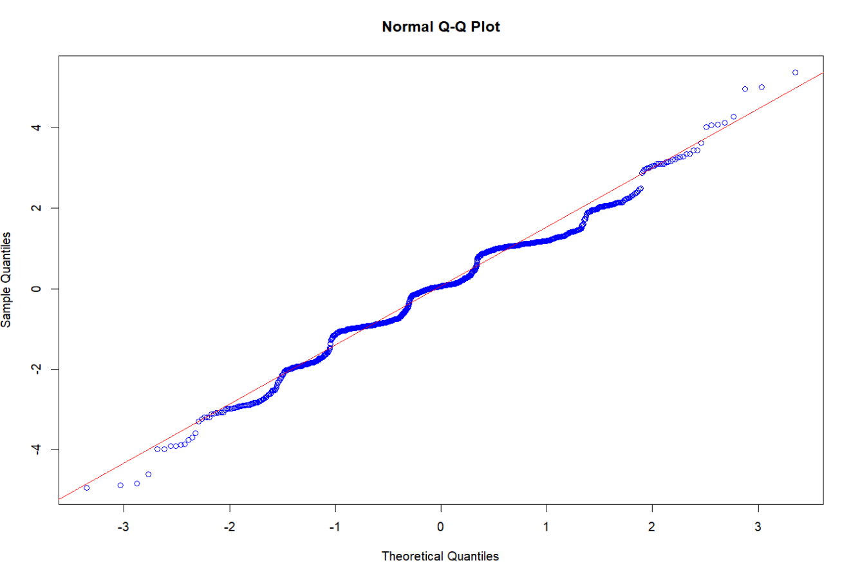Figure33. Q-Q Plot

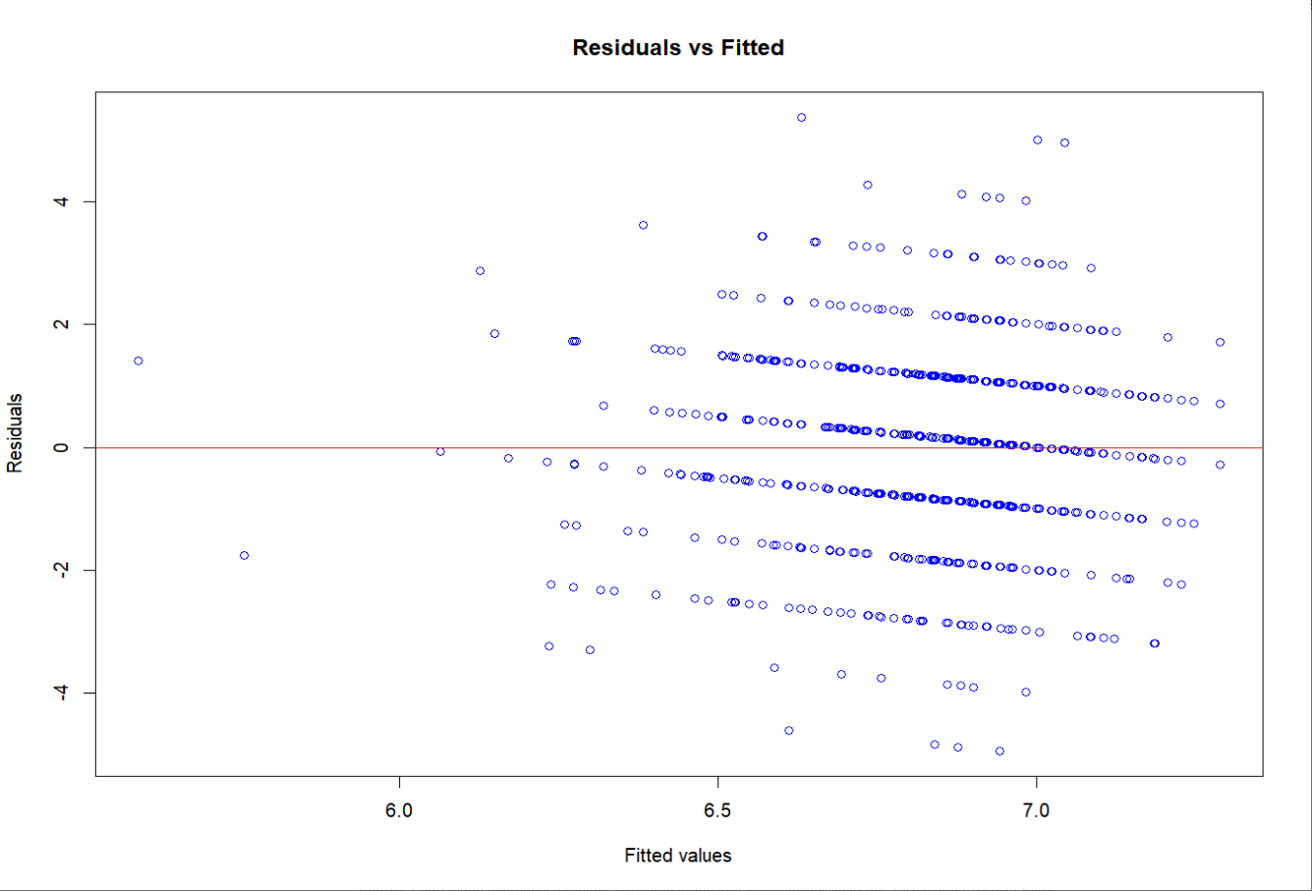Figure34. Residuals vs Fitted Plot

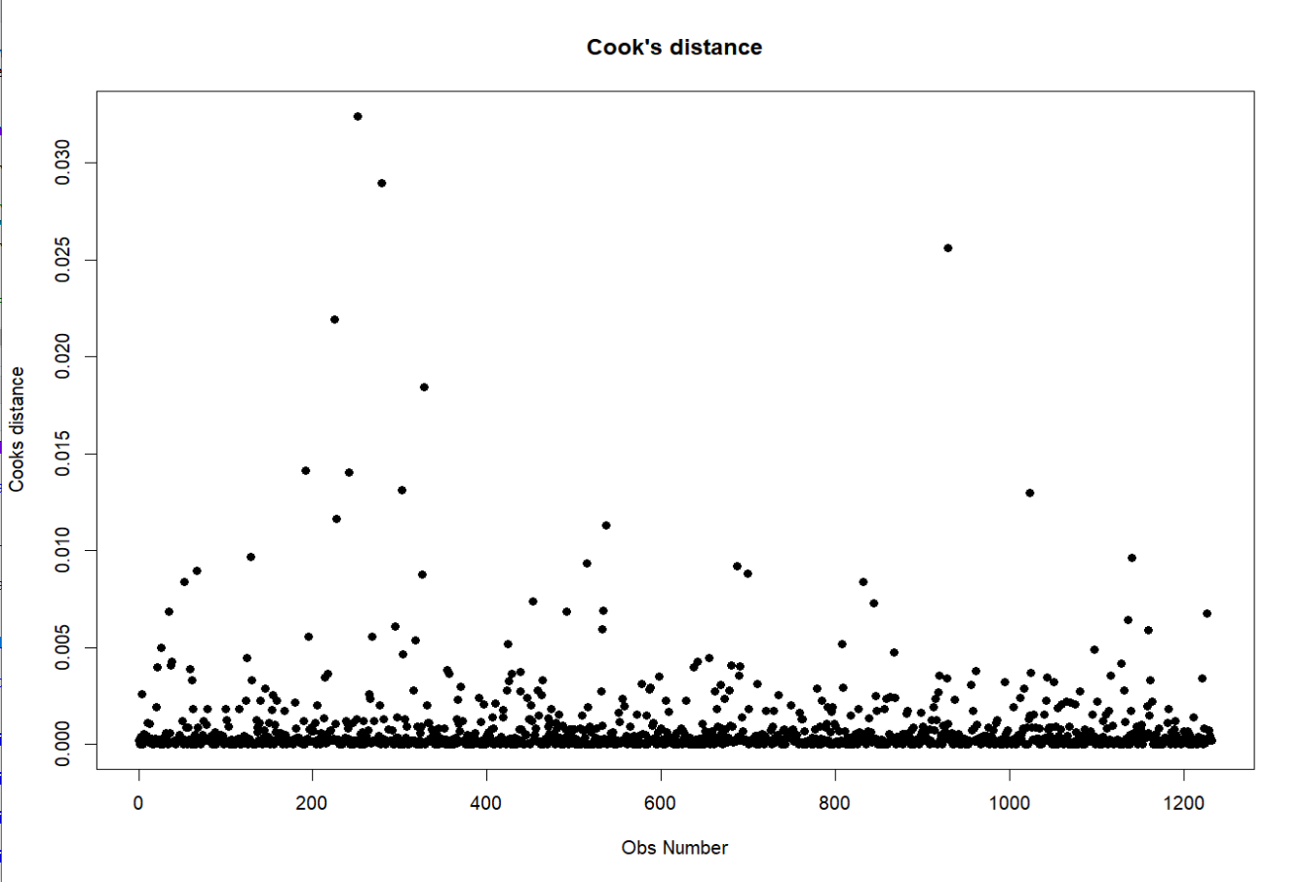Figure35. Cook’s distance Plot

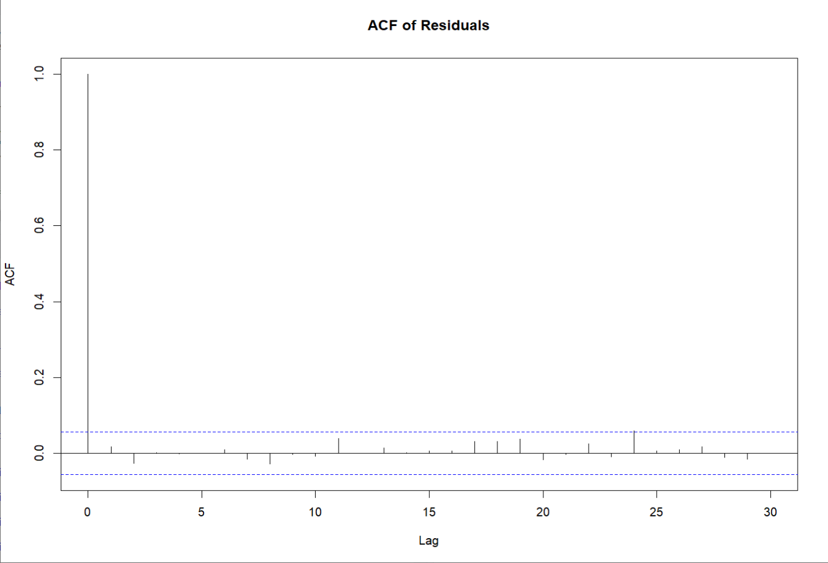Figure36. ACF of Residuals Plot

Based on the visuals, this Q-Q plot displays points close to a diagonal line, indicating that the distribution of residuals approximates a normal distribution. This suggests relatively good model fit, implying smaller biases in the model's predictions and better capturing of the data's variability, thus enhancing the model's reliability and accuracy. In the Residuals vs Fitted plot, the distribution of residuals appears uniform, indicating compliance with the Gaussian-Markov Condition. The Cook's distance plot suggests few potential outliers or high leverage points. In the ACF plot, the autocorrelation coefficients of residuals are close to zero for all lag orders, suggesting no residual correlation.

1. Depressed:

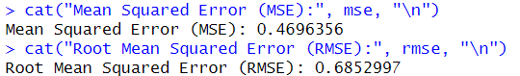

MSE is 0.4696356 and RMSE is 0.6852997 indicate that the model has relatively small average prediction errors and performs well in prediction.

1. LittleInterest:

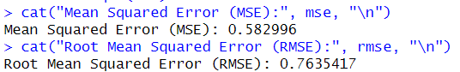

MSE is 0.582996 and RMSE is 0.7635417 indicate that the model has relatively small average prediction errors and performs well in prediction.

1. MentHlthBadRate:

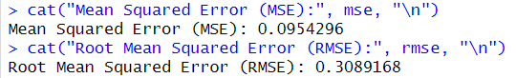

MSE is 0.0954296 and RMSE is 0.3089168, which indicate that the model has relatively small average prediction errors and performs well in prediction.

## **Results**

1. Firstly, the results indicate the existence of a "maternal penalty" in terms of mental health. Based on the data from the overall female population in the NHANES database, we can observe a strong correlation between four psychological indicators—sleep, depression level, low interest level, monthly mental health bad rate—and variables such as female age at first childbirth and the difference between pregnancy and childbirth. Additionally, there is a certain correlation with the number of children born to women. Specifically, the younger the age at first childbirth for women, the worse their performance is across the four psychological indicators, similarly, the larger the difference between pregnancy and childbirth, the worse their performance is across the four psychological indicators.
2. Based on the data analysis results, the recommended age for women to give birth is between 20 and 35, with a pregnancy to childbirth difference of 0 or 1.
3. According to the regression analysis:

sleep can be summarized in relation to female age at first childbirth, the number of children born to women, and the difference between pregnancy and childbirth for women:

Sleep=6.580218+0.020255×FirstBaby−0.021341×Babies−0.145789×Pregnancy_dif

Among this formula:

Sleep is the predicted sleep duration.

FirstBaby is the age at first childbirth.

Babies is the number of children born.

Pregnancy_dif is the difference between pregnancy and childbirth.

The other factors (depressed, LittleInterest, and MentHlthBadRate) are better suited for KNN regression analysis.

## **Discussion & Conclusion**

The findings of this study provide valuable insights into the relationship between fertility and mental health in females. The study revealed the risks associated with adolescent childbirth and indicated that the number of children born has a relatively low impact on the psychological well-being of women who have already become mothers.

Limitations include missing data on mental illness, which could not be included in the analysis.Therefore, it is possible to expand the discussion to include additional influencing factors, refine the formula, and provide more scientifically sound conditions conducive to maintaining women's mental health, such as optimal age ranges for childbirth.

## **References**

* Jiang Y, Yang F. Motherhood Health Penalty: Impact of Fertility on Physical and Mental Health of Chinese Women of Childbearing Age. Front Public Health. 2022 May 20;10:787844. doi: 10.3389/fpubh.2022.787844.
* Wei J, Xue J, Wang D. Socioeconomic determinants of rural women's desired fertility: A survey in rural Shaanxi, China. PLoS One. 2018 Sep 13;13(9):e0202968. doi: 10.1371/journal.pone.0202968.
* Yang H, Zheng X, Zhou R, Shen Z, Huang X. Fertility Behavior and Depression Among Women: Evidence From China. Front Psychol. 2020 Nov 13;11:565508. doi: 10.3389/fpsyg.2020.565508.
* Barth RP, Schinke SP, Maxwell JS. Psychological correlates of teenage motherhood. J Youth Adolesc. 1983 Dec;12(6):471-87. doi: 10.1007/BF02088665.